**SMART WORKSPHERE**

**MAJOR PROJECT REPORT**

SUBMITTED IN THE PARTIAL FULFILMENT OF THE REQUIREMENTS FOR THE AWARD OF THE DEGREE OF

**BACHELOR OF TECHNOLOGY**

(Computer Science and Engineering)

Submitted By: Submitted To:

Aditya Yadav(2104059) Dr. Vivek Thapar

Ajay Kumar(2104061) Assistant Professor

Aryan Garg(2104077)



**DEPARTMENT OF COMPUTER SCIENCE AND ENGINEERING**

**GURU NANAK DEV ENGINEERING COLLEGE**

**LUDHIANA,141006**

JUNE, 2025

**ABSTRACT**

In today's fast-evolving business environment, organizations require robust platforms to manage their workforce, streamline operations, and enhance productivity. Smart Worksphere is a comprehensive, full-stack application designed to address these needs by providing an integrated solution for employee management, attendance tracking, asset handling, client management, project tracking, accounting, and payroll generation. we have built this project using technologies like PHP, Laravel, React.js, Node.js, MySQL, HTML, CSS, Bootstrap, and JavaScript, the system offers an intuitive and user-friendly interface with powerful backend capabilities.

The project focuses on centralizing employee-related data through well-structured profiles that store personal information, emergency contacts, educational history, work experience, family details, and assigned company assets. Attendance management is curated through dynamic tabular views with multiple filters, allowing administrators to monitor employee performance efficiently. This system includes modules for managing departments, designations, holidays, and client records which ensures smooth organizational workflows.

A feature of Smart Worksphere is the One-to-One Chat Application, enables real-time communication among users and speed up decision-making processes. It also contains a feature called ticketing system that allows employees to assign tickets to relevant person and track resolutions effectively and ensures quick problem handling. Administrative functionalities include CRUD operations for users, backup management, and detailed settings for company information, localization, invoices, and theme customization.

From a financial standpoint, Smart Worksphere empowers organizations to manage budgets, categorize expenses, generate invoices and estimates, handle taxes, and maintain an organized accounting structure. The project management module provides taskboards, enabling teams to create, assign, and track tasks efficiently within projects.

In summary, Smart Worksphere is a versatile and scalable enterprise solution that redefines how companies manage their employees, assets, projects, and financials. It bridges gaps between different organizational functions and establishes a smart, connected workplace environment — helping businesses stay efficient, organized, and future-ready.

**ACKNOWLEDGEMENT**

We are highly grateful to the **Dr. Sehijpal Singh**, Principal, Guru Nanak Dev Engineering College (GNDEC), Ludhiana, for providing this opportunity to carry out the major project work at Department of Computer Science and Engineering, GNDEC.

The constant guidance and encouragement received from **Dr. Kiran Jyoti**, H.O.D, CSE Department, GNDEC Ludhiana has been of great help in carrying out the project work and is acknowledged with reverential thanks.

We would like to express a deep sense of gratitude and thanks profusely to Project Guide **Dr. Vivek Thapar**, without his wise counsel and able guidance, it would have been impossible to complete the project in this manner.

We express gratitude to other faculty members of computer science and engineering department of GNDEC for their intellectual support throughout the course of this work.

Finally, we are indebted to all whosoever have contributed in this report work.

**Aditya Yadav**

**Ajay Kumar**

**Aryan Garg**

**LIST OF FIGURES**

**Figure No. Figure Description Page No.**

**3.1 DFD 1 29**

**3.2 DFD 2 30**

**3.3 ER Diagram 32**

**5.1 Login 59**

**5.2 Dashboard 60**

**5.3 Expenses 61**

**5.4 Budget and Invoices Overview 61**

**5.5 Employees Overview 62**

**5.6 Users Overview 63**

**5.7 Departments 63**

**5.8 Attendances 64**

**5.9 Clients 65**

**5.10 Holidays 65**

**5.11 Designations 66**

**5.12 Backups 67**

**5.13 Payroll Items 67**

**LIST OF TABLES**

**Table No. Table Description Page No.**

**5.14 Database Overview 71**

**5.15 Database Overview 71**

**5.16 Database Overview 72**

**TABLE OF CONTENTS**

**Contents Page No.**

Abstract i

Acknowledgement ii

List of Figures iii

List of Tables iv

Table of Contents v

Chapter 1: Introduction

1.1 Introduction to Project 1

1.2 Project Category 2

1.3 Problem Formulation 3

1.4 Identification/Recognition of Need 5

1.5 Existing System 7

1.6 Objectives 9

1.7 Proposed System 11

1.8 Unique features of the proposed system 14

Chapter 2: Requirement Analysis and System Specification

2.1 Feasibility study 15

2.2 Software Requirement Specification Document 17

2.3 SDLC model to be used 20

Chapter 3: System Design

3.1 Design Approach 24

3.2 Detail Design 27

3.3 User Interface Design 34

3.4 Methodology 36

Chapter 4: Implementation and Testing

4.1 Introduction to Languages, IDE’s, Tools and Technologies 39

used for Project work

4.2 Algorithm/Pseudocode used 41

4.3 Testing Techniques 44

4.4 Test cases 47

Chapter 5: Results and Discussions

5.1 User Interface Representation 51

5.2 Snapshots of system with brief detail of each and discussion 57

5.3 Back Ends Representation 69

Chapter 6: Conclusion and Future Scope

5.1 Conclusion 73

5.2 Future scope 74

References 75

**Chapter 1: Introduction**

**1.1 Introduction to Project**

Businesses are always looking for methods to increase staff productivity, streamline processes, and guarantee effective internal communication in the fast-paced, digitally-evolving world of today. The majority of businesses manage everyday tasks including payroll, project tracking, personnel management, and attendance using a mix of manual techniques and software. However, employing several disjointed systems may result in poor data processing, inefficiencies, and communication failures. An integrated solution that consolidates all of an organization's essential functions onto a single, centralized platform is becoming more and more necessary in order to overcome these obstacles.

**Smart Worksphere** is designed to address this very need. It is a web-based business management application that combines various administrative and operational modules into one comprehensive system. This platform offers a wide range of features, including employee CRUD operations, structured employee profiles, real-time attendance tracking, payroll generation, project management with interactive taskboa ds, asset handling, ticketing system, and role-based user management. One of the standout features of this system is the integrated one-to-one chat app, which enables seamless internal communication among employees and administrators.

Developed using modern web technologies such as PHP, Laravel, Node.js, React.js, MySQL, HTML, CSS, Bootstrap, and JavaScript, Smart Worksphere ensures high performance, scalability, and a responsive user interface. It also supports essential customization settings like localization (timezone, currency, language) and theme adjustments to cater to diverse organizational needs. The system is designed to handle muliple user roles, allowing administrators to manage permissions and access levels securely and efficiently.

Smart Worksphere also includes a robust backup management feature that lets authorized users generate, download, or delete backups of the application and its database. This ensures data safety and easy recovery in case of technical issues. The inclusion of modules such as accounting, invoice management, tax handling, and client CRM makes the platform suitable for end-to-end business process automation.

Overall, Smart Worksphere provides a smart, user-friendly, and centralized solution to manage essential business activities from a single dashboard. It not only reduces administrative overhead but also improves transparency, collaboation, and data accessibility across departments. With its modular architecture and customizable settings, it can be easily adapted to fit the unique requirements of any organization, making it an ideal tool for companies aiming to go digital and work more efficiently.

**1.2 Project Category**

The Smart Worksphere project is categorized as an Application-Based and Industry-Oriented project. It falls under the domain of enterprise application development, specifically targeting small to medium-sized businesses that require digital solutins to manage their internal workflows and administrative operations.

This project has been developed with real-world business needs in mind, addressing the common pain points faced by organizations in handling employee records, attendance, payroll, projects, and internal communication. In most companies, such operations are either managed manually or using fragmented tools, which leads to inefficiencies and data silos. The proposed system brings together all these essential functions into a single, integrated platform, making it a practical and industry-relevant application.

From a technical perspective, Smart Worksphere is a full-stack web application built using a modern technology stack including PHP, Laravel, Node.js, React.js, MySQL, HTML, CSS, Bootstrap, and JavaScript. This makes it a robust example of an Application-Based project as it applies programming conpts, database management, and UI/UX design to build a functional and interactive software product.

Being Industry-Based, the system is tailored to simulate and solve real organizational challenges. It is designed with scalable architecture, role-based access control, backup capabilities, and localization features, which are all essential components of a deployable enterprise-grade application. The features like employee CRUD, one-to-one chat app, asset and attendance management, ticketing system, and project taskboards are all aligned with operational workflows typically seen in real business environments.

Moreover, the platform supports key financial operations such as **budgeting, invoice and tax management, sales tracking, and payroll generation**, which places it firmly within the industry software domain. These features not only automate manual tasks but also provide actionable insights through structured data presentation and reporting.

Although the project is not purely research-focused, it does incorporate several best practices from software engineering, database normalization, and modular code design. The aim is not just to build a functional system, but also to ensure it is **maintainable, extensible, and secure**, which are crucial requirements for industry deployment.

The Smart Worksphere system could be easily adopted by companies looking to transition from manual operations to a digital workspace. It’s designed to offer flexibility in terms of organizational structure and size, and can be further customized to meet specific industry requirements such as education, healthcare, IT services, and more.

In summary, the **Smart Worksphere** project is a **fully-functional, application-based, and industry-level software solution** aimed at solving real problems through technology. It demonstrates practical knowledge in full-stack develoent and provides a solid foundation for real-world software deployment. The project not only meets academic expectations but also holds the potential to be deployed and used in a real business environment, making it highly relevant for both academic learning and professional application.

**1.3 Problem Formulation**

In today’s dynamic and competitive business environment, organizations are expected to function with a high degree of efficiency, transparency, and accountability. However, many small and medium-sized enterprises (SMEs) continue to rely on manual processes or isolated digital tools to handle their internal operations. These tools are often not integrated and may only solve specific problems such as attendance tracking, payroll calculaion, or project task management in isolation. This fragmented approach leads to serious operational challenges that can hinder overall productivity and performance.

Some of the major issues faced by organizations include poor communication between departments, unorganized employee data, difficulties in tracking attendance and leaves, lack of automation in payroll processing, inefficient handling of projects and tasks, and mismanagement of client information. Additionally, most businesses do not have a centralized platform to manage assets, track issues related to them, or generate backups for future recovery. In the absence of such integration, the data is either stored in spreadsheets or across multiple systems, increasing the risk of inconsistency, duplication, and data loss.

Another common problem is the lack of role-based control in many existing systems. Admins, HR teams, project managers, and employees all require different levels of access and responsibilities within a system. Without proper permissions and user roles, the risk of unauthorized access or accidental data modification increases. Moreover, these systems often lack localization features—such as support for multiple time zones, currencies, or languages—which are important for businesses operating in different regions.

Furthermore, collaboration within teams is often hampered due to the absence of a dedicated communication system. Employees are forced to rely on third-party applications or external chat tools, which are not integrated with the organization’s internal data or workflows. This separation leads to missed updates, untracked conversations, and poor issue resolution.

Due to the lack of a unified accounting interface, businesses have difficulty creating and maintaining budgets, estimates, and invoices. The majority of these jobs are completed by hand or with basic accounting software that is not connected to other business processes. This makes keeping data current, producing reports on time, and guaranteeing financial compliance more difficult and prone to mistakes.

Given these challenges, there is a clear need for an all-in-one digital workspace that unifies core business operations in a single platform. Such a system should be scalable, secure, user-friendly, and customizable based on organizational structure and user roles. It should reduce redundancy, automate repetitive tasks, improve data accuracy, and enhance collaboration within the organization.

The **Smart Worksphere** project has been formulated to address all of the above issues. It is designed as an integrated business management system that offers modules for employee CRUD, attendance tracking, payroll generation, project and task management, asset assignment, ticket handling, user management, and internal communication through a one-to-one chat feature. With added functionalities like role-based access control, localiation settings, backup management, accounting tools, and client CRM, it provides a comprehensive solution for organizations to manage their day-to-day operations effectively.

By identifying the specific pain points faced by modern organizations and formulating a solution that brings all critical functions under one roof, **Smart Worksphere** aims to eliminate operational inefficiencies, improve employee engagement, and support better decision-making through structured data handling and real-time access.

**1.4 Identification / Recognition of Need**

In any growing organization, managing day-to-day internal operations becomes increasingly complex over time. Departments grow, employees are added, client bases expand, and the demand for efficient communication and collaboration intensifies. Traditionally, many small and medium-sized enterprises (SMEs) handle these tasks using a combination of manual processes, Excel sheets, or basic tools that are not interconnected. While such methods may seem manageable in the early stages of an organization, they quickly become inefficient, error-prone, and time-consuming as the organization scales.

This growing complexity signals the **need for a centralized and automated system** that can simplify and manage the core functionalities of an organization. Businesses require a platform that goes beyond traditional software solutions and integrates essential modules such as employee management, attendance tracking, payroll generation, asset handling, project and task management, client interaction, internal communication, ticketing, financial operations, and more — all under one unified interface.

Through various interactions, observations, and research into the operational workflows of different organizations, it has become clear that there is a **significant gap** in available software that can provide all these functionaties in one place while still being user-friendly and customizable. Existing solutions tend to be either:

* **Too generic**, covering only basic HR functions without scalability for project and finance management.
* **Too fragmented**, requiring companies to subscribe to multiple tools (one for HR, another for chat, another for project management, and another for invoicing), which increases costs and causes data fragmentation.
* **Too complex and expensive**, which discourages small and mid-sized businesses from adopting them.

There is also a strong need for **role-based access control**, where different users such as HR personnel, administrators, project managers, and employees have specific access to only those features relevant to their role. Many organizations also operate in different countries or time zones, so localization features such as time format, currency settings, and language support become crucial for a smooth user experience.

Another major pain point identified is the **lack of internal communication systems**. Employees often use third-party messaging apps like WhatsApp or Slack, which are not integrated with the company’s operational platform. This leads to a loss of context and poor tracking of important conversations. Having a built-in **one-to-one chat system** that is integrated with user profiles, tickets, and tasks is vital to ensure clear, traceable, and secure communication within the system.

Furthermore, organizations that deal with **project-based work** need an efficient way to assign projects, monitor progress, and track tasks. A drag-and-drop taskboard, similar to Kanban, where tasks can be moved between stages and assigned to employees, greatly improves visibility and coordination among teams.

To ensure data safety and recovery, a **backup module** is essential, yet many platforms do not offer this as a built-in feature. Additionally, automated payroll generation, invoice customation, and budget tracking are often overlooked in general business tools, even though they are fundamental for smooth financial operations.

All these factors combined demonstrate a **clear, real-world need** for an all-in-one business management system. Recognizing this need has led to the development of **Smart Worksphere**—a comprehensive web-based platform tailored for mdern organizations to manage their internal workflows efficiently and effectively.

The goal of Smart Worksphere is not just to digitize existing manual processes, but to **transform the way organizations operate**, enabling better collaboration, increased transparency, reduced administrative burden, and enhanced decision-making. By offering customizable modules with powerful features, the platform directly addresses the needs identified during problem research and serves as a long-term, scalable solution for business management.

**1.5 Existing System**

In the current digital landscape, several systems and tools exist to manage different aspects of organizational workflows such as Human Resource Management (HRM), project tracking, payroll processing, and internal communications. However, most of these systems function independently, addressing only a specific component of business operations, leading to a disjointed experience for users and administrators.

Let us examine the typical existing systems in use by organizations today:

**1. Employee Management Systems**

Most companies use standalone HR software or spreadsheets to handle employee data such as personal information, educational background, emergency contacts, and work history. These systems may include CRUD (Create, Read, Update, Delete) operations but often lack integration with other modules like attendance, payroll, asset assignment, or communication channels. This results in data duplication and makes it difficult to maintain centralized and updated employee records.

**2. Attendance and Leave Management**

Many organizations rely on biometric systems or cloud-based attendance software to track employee work hours and leaves. While these systems capture raw data efficiently, they often lack features like filters by employee name, date, or department. Furthermore, they do not always integrate with payroll systems, which can lead to manual effort when generating payslips or processing deductions for absences.

**3. Project Management Tools**

Tools like Trello, Asana, or Jira are commonly used for managing tasks and team collaboration. These platforms are powerful in terms of project visualization, task boards, and file uploads, but they are not connected to the organization’s employee records, timesheets, or accounting systems. This disconnect can cause inefficiencies in tracking project progress in relation to employee productivity and budget allocation.

**4. Payroll Software**

Payroll software like QuickBooks or Zoho Payroll provides features to automate payslip generation, tax calculation, and direct deposit. However, these systems function independently from HR or attendance tracking tools. Organizations often face challenges in synchronizing data across systems, leading to errors or delays in salary processing.

**5. Communication Tools**

For team communication, the majority of firms use third-party chat programs like Slack, Microsoft Teams, or WhatsApp. Although these technologies perform well for communicating, the organization's workflow systems are not integrated with them. It is challenging to keep track of issue resolutions or audit communication history because they do not offer context-based conversations linked to tasks, tickets, or personnel information.

**6. Asset Management**

Asset management is usually handled via spreadsheets or inventory software. These tools often do not link assets to employees, nor do they allow employees to raise isues regarding faulty equipment directly within the platform.

**7. Ticketing and Support**

Many businesses implement ticketing systems like Zendesk or Freshdesk to manage client and internal queries. However, these systems are typically client-focused and lack integration with internal employee management tools. Also, they often come with a cost barrier and require technical expertise for setup and customization.

**8. Invoicing and Budgeting Tools**

Accounting software like Tally, Wave, or FreshBooks offers invoicing, estimates, and budget tracking. These tools are useful for finance departments but do not integrate with project management or employee time tracking systems, resulting in data inconsistencies and inefficient reporting.

**Summary of Limitations in Existing Systems**

* Lack of integration between modules (HR, finance, projects, communication, etc.)
* Manual data entry across multiple tools causing redundancy and inconsistency
* High cost and complexity of managing multiple software systems
* Absence of a centralized dashboard for overall business visibility
* No built-in role-based access or localization features in many platforms
* Poor scalability and limited customization options

**1.6 Objectives**

The **Smart Worksphere** project has been developed with a clear set of objectives aimed at addressing the inefficiencies and limitations present in existing business management systems. By carefully analyzing the challenges faced by organizations in handling their day-to-day operations, the project seeks to offer a holistic solution that not only automates but also enhances the workflow within organizations. The following are the key objectives that guided the development of the Smart Worksphere platform:

* **To Develop a Platform for Employee Management, Attendance Tracking, and Payroll Generation**
* **To Implement Modules for Project Management, Asset Handling, and Client Interactions**
* **To Enhance User Accessibility and System Customization through Roles, Permissions, and Localization Settings**

**Other Supporting Points**

* **Internal Communication:** The development of a one-to-one internal chat system ensures that communication remains within the platform, reducing dependency on external messaging apps and allowing better tracking of conversations linked to specific tasks or tickets.
* **Ticket Management:** By allowing users to create and manage tickets, and enabling employees to converse directly with clients or the support team, the platform improves issue tracking and resolution efficiency.
* **Backup Management:** Providing an easy-to-use backup management module ensures that the system's critical data, including code and databases, can be backed up, downloaded, or deleted as per the user's permission level, ensuring data security and recovery readiness.
* **Accounting and Sales Management:** Smart Worksphere includes modules for budget planning, expense and revenue tracking, invoice and estimate management, and tax handling, making it easier for organizations to maintain financial transparency and discipline.

By aligning all these modules into a single cohesive platform, Smart Worksphere aims to **increase productivity**, **enhance collaboration**, **improve decision-making**, and **drive overall organizational growth**.

**1.7 Proposed System**

The **Smart Worksphere** platform is proposed as an all-in-one, centralized web application that aims to streamline and enhance organizational operations by integrating multiple modules into a unified system. It has been designed to overcome the limitations of existing fragmented tools and manual processes, offering a seamless digital environment for managing employees, projects, clients, communication, financials, and internal resources.

At its core, the proposed system provides a **well-structured Employee Management module**. Organizations can add, update, and maintain detailed employee profiles, including personal information, educational qualifications, work experiences, emergency contacts, and family details. Assets can be assigned to employees, and any issues regarding assets can be raised directly within the system, ensuring better accountability.

Attendance management is handled through a **curated tabular view** where employee attendance can be tracked, filtered by employee name, month, and year, making reporting and analysis more convenient. This attendance data is directly linked to the **Payroll Management module**, allowing for automatic payslip generation, considering allowances and deductions, reducing the burden of manual payroll calculations.

The system proposes a **comprehensive Project Management module**, where projects can be created, teams assigned, tasks added, and taskboards managed using an intuitive drag-and-drop interface. This enhances collaboration among employees and project leads, offering a real-time view of task progress and project health.

In terms of **client management**, the system offers card and table views for managing client data efficiently. **Ticket management** is also integrated, allowing clients or employees to raise issues or support tickets. Employees assigned to tickets can have one-to-one conversations with the issue raiser, ensuring transparency and quicker resolution, while administrators retain the ability to monitor all tickets.

The **internal communication system** is enhanced with a built-in one-to-one chat feature. This eliminates reliance on third-party messaging platforms and keeps conversations related to company operations within the secure environment of the Smart Worksphere platform.

Smart Worksphere also emphasizes **system security and user accessibility** by incorporating a robust **Roles and Permissions management module**. Each user role can be customized with specific permissions, ensuring that employees, managers, and admins have access only to the data and modules necessary for their duties.

Moreover, recognizing the diversity of modern businesses, Smart Worksphere includes **Localization settings** to configure language, timezone, date format, currency, and currency codes based on the organization's operational region.

The **Accounting and Finance modules** allow organizations to create and manage budgets, categorize expenses and revenues, manage taxes, create estimates, and generate invoices. This financial control is vital for project-based billing, budgeting, and overall financial health tracking.

Finally, the platform offers a **Backup Management module**, providing options to backup the entire application or just the database. Users can also download or delete backups based on their access rights, ensuring data safety and disaster recovery readiness.

In short, the proposed system — Smart Worksphere — is a complete solution aimed at **simplifying organizational management**, **improving operational efficiency**, **enhancing collaboration**, and **supporting scalability** for businesses of all sizes.

**1.8 Unique Features of the Proposed System**

The **Smart Worksphere** platform distinguishes itself through a variety of innovative and thoughtfully designed features that offer a comprehensive solution for business and organizational management. Unlike traditional systems that operate in isolated silos, Smart Worksphere integrates multiple core business functionalities under a unified platform. This integration not only simplifies operations but also greatly enhances efficiency, collaboration, and data consistency across departments.

Below are the **unique features** that make Smart Worksphere stand out:

**1. Unified Employee Management with Asset Assignment**

Personal information, educational background, work experiences, emergency contacts, and family member details are all carefully documented in Smart Worksphere's comprehensive personnel management system. The ability to immediately assign assets to employees, such as computers, mobile phones, or other corporate equipment, and monitor their progress via their profile is what makes it unique. Better asset lifetime management and real-time maintenance are made possible by employees' ability to even file complaints against allocated assets.

**2. Advanced Attendance Tracking with Dynamic Filters**

Instead of basic check-in/check-out systems, Smart Worksphere provides a curated, tabular view of employee attendance that can be filtered by employee name, month, and year. This makes attendance tracking extremely flexible and valuable for HR analysis, payroll calculation, and performance reviews, offering greater insights into employee work patterns.

**3. Integrated Payroll System**

Unlike traditional payroll systems that require manual data entry, Smart Worksphere seamlessly links attendance records with the payroll module. It allows for the creation of payslips that automatically account for working days, absences, allowances, and deductions. This integration eliminates errors, reduces administrative work, and ensures timely salary disbursement.

**4. Real-time Project Management with Taskboards**

The project management module provides not just basic task lists, but an entire taskboard system where tasks can be moved across stages using a drag-and-drop interface. It supports assigning leads, building project teams, uploading documents, setting deadlines, and monitoring task progress — all in real time. This visual and interactive project handling makes team collaboration much more efficient and intuitive.

**5. One-to-One Internal Chat System**

The built-in messaging system allows employees to communicate directly within the platform, keeping organizational discussions centralized and secure. It eliminates dependency on external apps like Slack or WhatsApp, offering better control over communication related to projects, tickets, or company matters.

**6. Ticketing System with Controlled Assignment**

Tickets raised by employees or clients can only be assigned to users with employee roles, not administrators. However, administrators retain oversight and can monitor all ongoing conversations. This thoughtful separation of responsibilities ensures smoother client support and internal issue resolution.

**7. Role-Based Access and Permissions**

Every user’s access to features and data is governed by roles and permissions. Admins can create custom roles, modify permissions, and grant specific access to different parts of the system. This enhances data security, simplifies user interfaces based on roles, and prevents unauthorized actions within the platform.

**8. Localization and Personalization**

Recognizing the needs of globally operating businesses, Smart Worksphere offers localization settings for countries, timezones, languages, date formats, currencies, and currency codes. Organizations can personalize the platform to align with their regional requirements, ensuring a more familiar and efficient experience for their employees.

**9. Backup Management Panel**

Smart Worksphere includes a straightforward yet powerful backup management tool. Users with appropriate permissions can create full backups (including code and database), download them for safe storage, or delete outdated backups. This ensures business continuity and data security without requiring separate IT interventions.

**10. Comprehensive Sales and Accounting Management**

The system provides modules for managing taxes, generating estimates, creating invoices, and tracking budgets. It allows businesses to easily manage financial transactions linked to projects, offering better transparency and easier financial reporting.

**Chapter 2: Requirement Analysis and System Specification**

**2.1 Feasibility Study**

Before starting the development of any project, it is critical to evaluate whether it is practically achievable within the available resources and constraints. The feasibility study for the Smart Worksphere project examines the technical, economic, and operational feasibility to ensure that the project can be developed, deployed, and maintained successfully.

**Technical Feasibility**

Technical feasibility evaluates whether the required technology and technical resources are available to develop the Smart Worksphere platform.

Smart Worksphere is built using modern, reliable, and well-supported technologies including PHP (Laravel Framework) for backend development, React.js for dynamic and responsive front-end interfaces, Node.js for server-side scripting and real-time functionalities, MySQL for secure and scalable database management, and frontend technologies like HTML, CSS, Bootstrap, and JavaScript for styling and interactivity.

All the selected technologies are open-source and widely adopted across the software industry, ensuring extensive community support, continuous updates, and a large pool of libraries and plugins that speed up development.

Additionally, modern web hosting services are fully compatible with the system's technology stack, ensuring that server deployment, database hosting, and maintenance can be achieved smoothly. System scalability is also guaranteed by the modular architecture, allowing for easy upgrades or additions in the future.

Hence, the project is highly technically feasible because all the tools, frameworks, and expertise needed for development are readily available.

**Economic Feasibility**

Economic feasibility analyzes whether the proposed system is financially viable for the organization or the intended users.

Cost-effectiveness was a consideration in the creation of the Smart Worksphere platform. The cost of purchasing software licenses is reduced because the majority of the technologies are open-source and free. Development time, human resources (developers, testers, and project managers), hosting costs, and domain registration are the key financial outlays.

By automating asset handling, payroll generation, personnel administration, attendance monitoring, project management, and client communication, the Smart Worksphere platform, once implemented, minimizes manual administrative processes. Over time, these automations result in significant cost savings by eliminating the need for sizable administrative and human resources staff.

Moreover, operational errors and redundancies are minimized, leading to faster task completion, better resource utilization, and improved productivity. Considering the long-term benefits and return on investment (ROI), Smart Worksphere is highly economically feasible.

**Operational Feasibility**

Operational feasibility determines how well the solution fits within the organization’s operational capabilities and practices.

Smart Worksphere is developed with the primary goal of improving organizational workflows. It simplifies complex activities such as employee onboarding, attendance tracking, communication management, issue handling, financial budgeting, and client management into an easy-to-use web interface.

The platform is user-friendly with an intuitive design that requires minimal training for employees and administrators to use effectively. Real-time features such as project taskboards and internal chats improve collaboration, while role-based access ensures that users interact only with the data relevant to their responsibilities.

Backup management, security features, and localization support (time zones, currencies, languages) ensure that the platform can operate across different locations and teams without issues.

Furthermore, the platform supports scalability to adapt as an organization grows, making it a long-term solution rather than a short-term fix. Continuous data access, streamlined communication, and process automation ensure that daily operations are faster, more reliable, and more organized.

Given the ease of use, alignment with business operations, and the improvement it offers over manual processes, the Smart Worksphere system is highly operationally feasible.

**2.2 Software Requirement Specification (SRS) Document**

**1. Introduction**

The purpose of this Software Requirement Specification (SRS) document is to define the requirements for the **Smart Worksphere** system. This document outlines all necessary software features, system behaviors, and technical constraints, ensuring that the final product meets user expectations and organizational goals.

Smart Worksphere is a web-based platform designed to streamline employee management, attendance tracking, payroll generation, project management, asset management, client handling, internal communication, ticket management, accounting, and administrative tasks within an organization.

The platform will provide an intuitive interface for admins and employees while ensuring performance, security, and maintainability.

**2. Overall Description**

Smart Worksphere is developed using PHP (Laravel) for backend operations, React.js for a responsive front-end experience, Node.js for real-time functionalities, MySQL as the database system, and HTML, CSS, Bootstrap, and JavaScript for design and interactivity.

The system will support multi-user access with role-based permissions. It will automate workflows, reduce manual workload, provide real-time communication features, and allow easy access to organizational data.

**3. Specific Requirements**

**3.1 Data Requirement**

* **Employee Data:** Full profile including personal details, contact information, emergency contacts, educational background, work experience, family details, and assigned assets.
* **Attendance Data:** Daily check-in, check-out, leave records, monthly and yearly attendance reports.
* **Project Data:** Project details, assigned teams, taskboards, project status, documents.
* **Client Data:** Contact information, client-associated projects.
* **Financial Data:** Budgets, expenses, revenues, taxes, estimates, and invoices.
* **Tickets and Issues:** Ticket details, conversations, issue status, assigned employees.
* **User Data:** Admin and employee credentials, roles, permissions, localization preferences.
* **Backup Data:** Full system backup and database-only backup data.
* **Asset Management Data:** Asset details, ownership history, issue status.

**3.2 Functional Requirement**

* **Authentication & Authorization:** Users must log in securely. Roles define system access levels.
* **Employee Management:** CRUD (Create, Read, Update, Delete) operations on employee records.
* **Attendance Tracking:** Real-time attendance management with search and filter options.
* **Chat System:** One-to-one real-time chat between users.
* **Asset Management:** Assign assets to employees, monitor asset status, raise issues about assets.
* **Project Management:** Create projects, manage tasks through drag-and-drop taskboards, assign tasks to team members.
* **Client Management:** CRUD management of clients with a detailed and tabular view.
* **Ticket Management:** Raise, assign, and manage support tickets within the system.
* **Accounting:** Manage budgets, categorize expenses and revenues, maintain financial records.
* **Backup System:** Initiate, download, and delete system backups.
* **Payroll Management:** Generate payslips with allowances and deductions.
* **Localization Settings:** Manage country, timezone, currency, and language settings.
* **Theme Settings:** Customize application appearance based on user/company preference.
* **Role and Permission Management:** Create roles and assign granular permissions to users.

**3.3 Performance Requirement**

* The platform must handle up to **500 concurrent users** efficiently without downtime.
* Search queries (e.g., for attendance, employee names) must return results within **3 seconds**.
* Page load times must be optimized to load within **2-4 seconds** under normal conditions.
* Backup and restore operations must not disrupt ongoing user sessions.

**3.4 Dependability Requirement**

* **Reliability:** System uptime of **99.5%** or higher must be ensured.
* **Backup:** Regular automatic backups every 24 hours.
* **Error Recovery:** The system should recover from failures without data loss.
* **Data Integrity:** All CRUD operations must preserve data integrity and consistency.

**3.5 Maintainability Requirement**

* **Modular Codebase:** Implement modular and scalable architecture for easy future expansion.
* **Code Documentation:** Comprehensive documentation for each module and API.
* **Database Normalization:** Proper normalization for data integrity and efficient querying.
* **Upgrade Ready:** Platform design must allow smooth integration of new features or third-party services.

**3.6 Security Requirement**

* **User Authentication:** Secure login with hashed passwords (bcrypt encryption).
* **Authorization Control:** Strict role-based access control (RBAC) ensuring sensitive data is protected.
* **Session Management:** Sessions timeout after inactivity to prevent unauthorized access.
* **Data Protection:** Sensitive operations (like backup downloads) must be authorized securely.
* **Vulnerability Protection:** System must be protected against SQL Injection, Cross-site Scripting (XSS), and Cross-site Request Forgery (CSRF).
* **Audit Logs:** Critical user actions (login attempts, data modifications) must be logged for monitoring.

**3.7 Look and Feel Requirement**

* **Responsive Design:** The application must be fully mobile-responsive and desktop-optimized.
* **Professional UI:** Modern and clean UI using Bootstrap with consistency in fonts, colors, and spacing.
* **User Friedly:** Intuitive navigation, easy-to-access menus, and real-time feedback for user actions.
* **Customization:** Option to change theme color and logo to match company branding.
* **Interactive Components:** Smooth animations for taskboard interactions, modal pop-ups for forms, and real-time notifications.

**2.3 SDLC Model to be Used**

**Introduction to SDLC**

A structured framework known as the Software Development Life Cycle (SDLC) describes the methodical evolution of tasks necessary to create a software product of superior quality. It guarantees that the software is delivered effectively, satisfies the requirements, and is thoroughly tested and assessed. Because it affects delivery speed, quality, flexibility, and the capacity to adjust to changes during development, choosing the appropriate SDLC model is essential for any project.

For the development of the **Smart Worksphere** platform, the **Iterative Model** combined with principles of **Agile Methodology** has been chosen. This decision is based on the dynamic nature of requirements, the modular structure of the project, the need for constant feedback, and the importance of user-centric evolution of features.

Each of the many interrelated modules that make up the Smart Worksphere project—such as employee administration, payroll, attendance, projects, chats, accounting, and ticketing—is intricate and necessary. A flexible development strategy is required because the project scope calls for ongoing improvement based on user needs and organizational expansion. Conventional models, like as Waterfall, are too inflexible to properly handle requirements changes in the middle of a project.

Thus, combining the **Iterative Model** and **Agile practices** is ideal because:

* It allows breaking the project into smaller modules (iterations/sprints).
* Each iteration can be improved based on stakeholder feedback.
* Risks can be identified early and resolved.
* Continuous testing and integration ensure system stability at every step.
* Changes in user requirements can be accommodated without major setbacks.
* The project can evolve progressively, delivering a better final product.

**Phases of the Iterative and Agile SDLC for Smart Worksphere**

**1. Requirement Gathering and Planning**

Initially, high-level requirements were collected, including core modules such as employee CRUD, attendance tracking, payroll management, project taskboards, and real-time chat features. However, detailed requirements were refined at the beginning of each sprint.

Planning meetings were held with stakeholders (admins, HR teams, managers) to prioritize modules and features based on business value and urgency. A product backlog was created and maintained dynamically.

**2. Analysis and Design**

At the beginning of each sprint, a detailed analysis of the selected features was performed. Entity-Relationship (ER) diagrams, Data Flow Diagrams (DFD), and UI/UX prototypes were developed iteratively.

For instance:

* In the first sprint, employee CRUD management and login systems were analyzed and designed.
* In the next sprint, attendance filters, payroll slips, and asset assignment systems were designed.

This phase focused heavily on modular and scalable design patterns to ensure that each component would integrate smoothly with others later.

**3. Development**

Development was carried out sprint by sprint. Technologies like **Laravel** for backend API development, **React.js** for frontend component creation, and **Node.js** for real-time features (like chat and notifications) were used.

At the end of each sprint:

* A working version of the module was available.
* Code reviews were conducted to maintain quality standards.
* Integrations were tested with already completed components.

Continuous Integration and Continuous Deployment (CI/CD) practices were encouraged to make code deployments faster and more reliable.

**4. Testing**

Each iteration included multiple layers of testing:

* **Unit Testing:** Every small functionality, like adding an employee or sending a chat message, was tested individually.
* **Integration Testing:** Interactions between modules, such as an employee profile linking to asset management, were tested.
* **System Testing:** End-to-end scenarios were tested after completing every sprint.
* **User Acceptance Testing (UAT):** End users provided feedback on usability and system behavior at the end of critical sprints.

Bugs and improvement points were documented and added to the product backlog for upcoming iterations.

**5. Deployment**

At the end of major milestones, deployable versions of Smart Worksphere were hosted on a staging environment. This allowed stakeholders to experience the system, validate progress, and suggest enhancements or report any issues before final production deployment.

**6. Maintenance**

Post-deployment, the iterative model ensures that the platform remains flexible for future upgrades, bug fixes, and feature enhancements without disrupting existing operations.

**Chapter 3: System Design**

**3.1 Design Approach**

The design approach adopted for **Smart Worksphere** is primarily based on the **Object-Oriented Design** methodology. In the context of modern software development, OOD offers a highly organized, modular, and scalable framework for building complex applications, making it the ideal choice for a multi-functional platform like Smart Worksphere.

**Object-Oriented Design**

The goal of object-oriented design is to create software by representing it as a collection of interconnected objects. These objects have both data and behavior, and they are representations of real-world phenomena. Every essential feature of Smart Worksphere, including ticket support, payroll processing, asset handling, staff management, project tracking, and attendance monitoring, is contained within separate modules. These modules are created as classes or objects that communicate with one another via well specified interfaces.

This approach offers several advantages:

* **Modularity:** By dividing the system into separate modules (e.g., Employee, Attendance, Payroll, Projects), development and maintenance become easier.
* **Reusability:** Code and components can be reused across different parts of the application, reducing redundancy.
* **Scalability:** New features or modules can be added without affecting the existing system architecture significantly.
* **Security and Encapsulation:** Sensitive data such as salary information and client communications are protected through access restrictions, ensuring secure data handling.
* **Ease of Maintenance:** If a module requires updates or improvements, it can be modified independently without impacting the rest of the system.

Thus, Object-Oriented Design perfectly supports the goals of Smart Worksphere by providing a flexible, secure, and scalable system architecture.

**Layered Architecture**

The system follows a **layered architecture** pattern to separate concerns among various parts of the application:

1. **Presentation Layer (Frontend):** Built with React.js, Bootstrap, and JavaScript, this layer handles the user interface and ensures a smooth, responsive user experience.
2. **Application Layer (Middleware):** PHP and Node.js are used here to handle business logic, process user requests, and perform operations like CRUD activities.
3. **Data Layer (Backend Database):** MySQL serves as the persistent storage for all application data, including employee records, attendance logs, project details, asset tracking, client information, and payroll data.

Each layer interacts with the adjacent layers through APIs or services, maintaining loose coupling and enhancing the system's maintainability.

**Modularization Strategy**

Smart Worksphere is designed using a modular approach where each feature of the application operates independently but can interact when necessary. For example:

* The **Employee Module** manages personal information, attendance, and asset allocation.
* The **Attendance Module** is linked to employees but is managed separately through its own set of rules and filters.
* The **Payroll Module** pulls data from the attendance and employee modules to generate payslips.
* The **Project Management Module** handles tasks and employee assigents, which relate back to the employee database.

This modularization helps to isolate problems, makes testing easier, and supports future upgrades without extensive rework.

**Design Principles Followed**

Several core object-oriented principles (often referred to as **SOLID principles**) were observed during the design phase:

* **Single Responsibility Principle:** Each class or module has a single responsibility, ensuring clarity and minimizing bugs.
* **Open/Closed Principle:** Modules are open for extension but closed for modification. New features like additional attendance reports can be added without changing the existing code.
* **Liskov Substitution Principle:** Subtypes or child classes can be substituted wherever their parent class is used, especially useful in user role and permission management.
* **Interface Segregation Principle:** Only necessary methods are exposed to users, ensuring no extra overhead.
* **Dependency Inversion Principle:** High-level modules do not depend on low-level modules; both depend on abstractions.

These principles guide the system’s design toward being more robust, maintainable, and adaptable.

**Justification for Object-Oriented Design**

Given the complexity and feature-rich nature of Smart Worksphere, a functional (procedure-oriented) approach would have made the sytem difficult to maintain, highly interconnected, and prone to errors when scaling.  
In contrast, Object-Oriented Design allowed for:

* Organized codebase
* Simplified debugging and enhancement
* Enhanced user security and role-based access
* Future scalability for adding modules like mobile app support or additional reporting features

Thus, OOD not only fits the technical needs of the platform but also supports the business goals of providing a reliable, scalable, and user-friendly smart workspace management solution.

**3.2 Detailed Design**

The requirements and high-level architecture are converted into precise technical models, diagrams, and plans that direct the system development process during the detailed design phase. Data Flow Diagrams (DFDs), Entity-Relationship Diagrams (ERDs), and Use Case Diagrams were among the structured analysis and design techniques used for the Smart Worksphere project in order to fully visualize and organize the system.

The detailed design focuses on how each objective listed in the project synopsis is achieved through thoughtful system modeling and architecture.

**3.2.1 Data Flow Diagrams (DFDs)**

**Data Flow Diagrams** illustrate how information moves through the system, the processes that transform data, and the data stores used.

**Level 0 DFD (Context Level)**

At the highest level, Smart Worksphere interacts with three main external entities:

* **Admin**
* **Employee**
* **Client**

Each entity communicates with the **Smart Worksphere System**, which in turn interacts with the **Database**.

Main Interactions:

* **Admin:** Manages employees, assets, projects, payrolls, settings, and tickets.
* **Employee:** Updates personal profiles, views attendance, raises asset issues, manages assigned tasks.
* **Client:** Creates tickets and views ticket status.

**Level 1 DFD**

Level 1 DFD expands the system into detailed sub-processes:

1. **Employee Management:** Add/Edit/Delete employees, manage employee profiles.
2. **Attendance Tracking:** Record daily attendance, generate reports, filter by employee name, month, or year.
3. **Asset Management:** Assign assets to employees, manage asset inventories.
4. **Project Management:** Create projects, assign teams, manage taskboards and tasks.
5. **Ticketing System:** Clients raise tickets; employees and admins interact over ticket resolutions.
6. **Payroll Generation:** Calculate payslips based on attendance, allowances, and deductions.
7. **Backup Management:** Handle application and database backups.
8. **Settings Management:** Manage localization, theme, and company details.

Each of these processes interfaces with data stores (Employee Data, Project Data, Attendance Data, Asset Data, etc.) and external users.

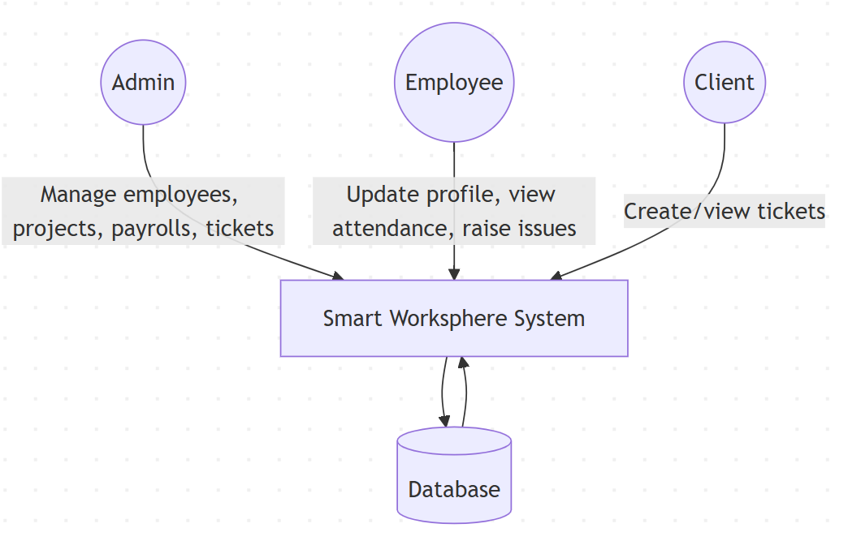

Fig.3.1 DFD 1

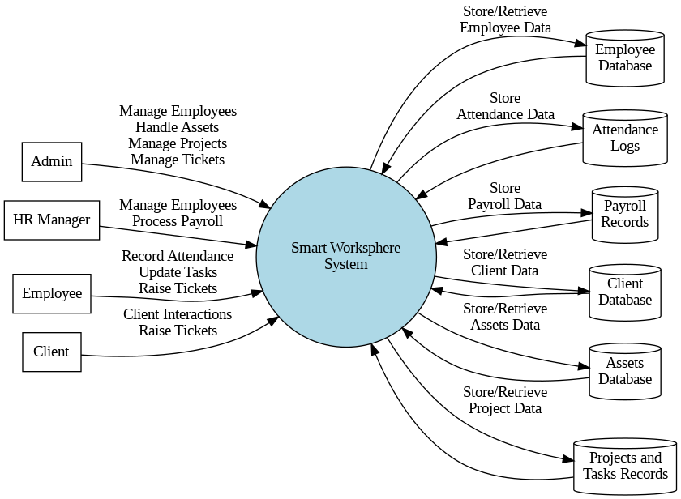

Fig.3.2 DFD 2

**3.2.2 Entity-Relationship Diagram (ERD)**

An **Entity-Relationship Diagram** models the logical structure of the database, showing entities, attributes, and relationships.

**Major Entities:**

* **User:** Basic information about system users (Admin, Employee, Client).
* **EmployeeProfile:** Stores extended employee information (personal details, emergency contacts, education, work experience family members).
* **Attendance:** Records employee attendance on a daily basis.
* **Asset:** Stores company assets and their assignment status.
* **Project:** Represents different projects created by the organization.
* **Task:** Tasks associated with projects.
* **Client:** Information about clients raising tickets.
* **Ticket:** Issues raised by clients and employees.
* **Payslip:** Stores generated payroll records.
* **Budget:** Tracks budgets, expenses, and revenues related to projects.

**Key Relationships:**

* One **User** manages multiple **Employees**.
* One **Employee** can have multiple **Attendance** records and assigned **Assets**.
* One **Project** can have multiple **Tasks**.
* One **Client** can create multiple **Tickets**.
* One **Employee** can be assigned multiple **Tasks** and handle **Tickets**.
* One **Payslip** is generated per employee per month.

This logical structure supports data integrity and enforces necessary business rules through relational constraints.

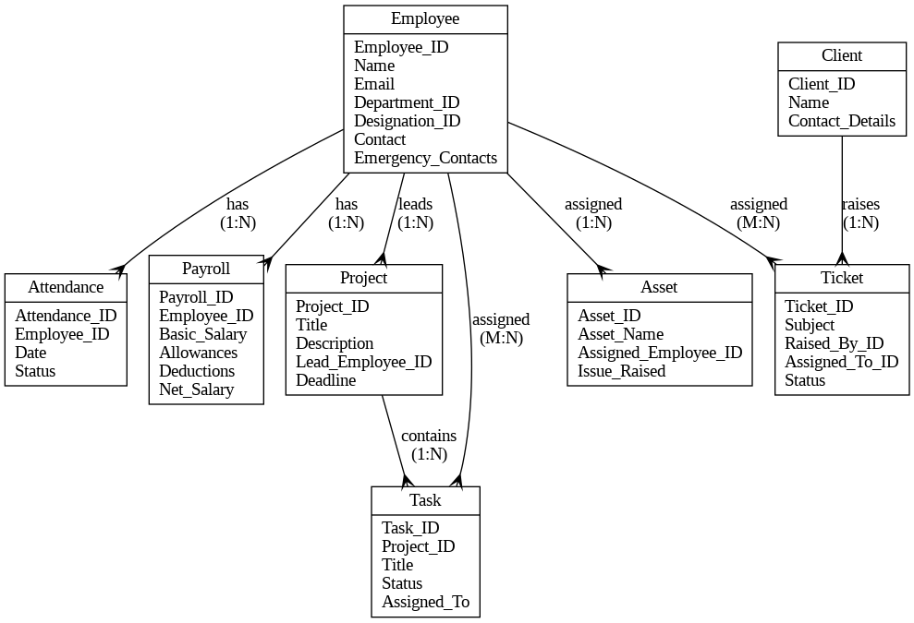

Fig.3.3 ER Diagram

**3.2.3 Use Case Diagram**

The **Use Case Diagram** identifies different user roles (actors) and the actions (use cases) they can perform in the system.

**Actors:**

* **Admin**
* **Employee**
* **Client**

**Use Cases:**

* **Admin:** Manage employees, clients, projects, payroll, backups, settings, and view tickets.
* **Employee:** Update profile, mark attendance, view assigned projects, manage tasks, report asset issues.
* **Client:** Submit and monitor tickets.

**Use Case Relationships:**

* "Manage Employees" includes adding, updating, deleting employee records.
* "Manage Projects" includes creating projects, assigning teams, creating and assigning tasks.
* "Manage Tickets" includes responding to client queries and tracking resolutions.

This helps visualize user interactions and prioritize system functionalities.

**3.2.4 Component Design**

Components were broken down for modularization:

* **Authentication Component:** Manages login, registration, session management.
* **Profile Management Component:** Handles employee data updates.
* **Attendance Component:** Logs, fetches, and reports attendance.
* **Project Component:** CRUD for projects and taskboards.
* **Asset Component:** Assigns and manages assets.
* **Ticket Component:** Manages client and employee ticket workflows.
* **Backup Component:** Triggers and restores system backups.

Each component interacts with API endpoints securely using RESTful architecture.

**3.2.5 Database Design**

The MySQL database schema includes:

* **Tables:** users, employees, clients, projects, tasks, attendance, assets, tickets, payslips, budgets, expenses, revenues.
* **Primary Keys and Foreign Keys:** Ensure relational integrity and efficient data querying.
* **Indexes:** Applied on critical fields like employee ID, project ID, ticket ID for fast retrieval.

Backups are scheduled daily, with options for manual backups through the system's UI.

**3.3 User Interface Design**

Any web application's success depends heavily on its user interface (UI) design, and Smart Worksphere has placed a high premium on a user experience that is simple, smooth, and effective.Clear information presentation, simple system feature interaction, and platform accessibility for all users—administrators, staff, and clients—are the objectives of the user interface design.

To provide a responsive, visually appealing, and useful user interface, the Smart Worksphere system makes use of contemporary frontend technologies such as React.js, Bootstrap, HTML5, CSS3, and JavaScript.

**3.3.1 Design Principles**

Several key UI design principles have been followed:

* **Simplicity:** The design is minimalistic, focusing on essential tasks and reducing visual clutter. This improves user concentration and efficiency.
* **Consistency:** Consistent color schemes, typography, button styles, and layout grids are maintained across the entire application for familiarity and ease of use.
* **Feedback:** Immediate feedback is provided on user actions (such as saving changes, form submissions, or errors) through modals, toasts, and alert messages.
* **Visibility:** Important information such as pending tickets, assigned projects, upcoming holidays, and today's attendance status is easily accessible from dashboards.
* **Accessibility:** The UI is designed to accommodate users of varying technical skills, using clear navigation menus, readable fonts, contrast-friendly color schemes, and keyboard-friendly navigation where possible.
* **Responsiveness:** The UI automatically adjusts to different screen sizes (desktops, tablets, mobiles), ensuring a seamless experience across devices.

**3.3.2 Layout and Navigation**

The application follows a **dashboard-style layout** common in management systems:

* **Top Navigation Bar:** Contains quick links to notifications, user profiles, language settings, and logout functionality.
* **Sidebar Menu:** A collapsible sidebar provides access to major modules like Employees, Attendance, Projects, Assets, Tickets, Payroll, Clients, and Settings. Icons and labels are used for easy recognition.
* **Main Content Area:** Displays data tables, forms, reports, and taskboards depending on the user's selected module.
* **Footer:** Displays company information and application version, maintaining professionalism.

Breadcrumbs and active highlights in the sidebar help users always understand where they are within the application.

**3.3.3 Forms and Data Views**

Forms are critical in Smart Worksphere for CRUD (Create, Read, Update, Delete) operations:

* **Employee Form:** Fields for entering personal information, education, work experience, emergency contacts, and family details.
* **Attendance Form:** Simple clock-in and clock-out buttons for daily attendance logging.
* **Asset Assignment Form:** Dropdown selections to assign assets to employees easily.
* **Project and Task Forms:** Allow project creation with a title, description, attachments, and task assignment.

Data is displayed in **tabular formats** wherever appropriate (employees list, attendance records, asset inventories, client management). Tables are enhanced with features like:

* Search bars
* Pagination
* Sorting
* Filters (e.g., filter attendance by month and year)

Cards are used to display summary information like client profiles, project details, and budget statuses in a visually appealing manner.

**3.3.4 Interactive Components**

Several interactive UI components enhance usability:

* **Modals:** For confirmation dialogs and quick forms without navigating away.
* **Date Pickers:** Simplify date input for attendance, leave applications, and payroll.
* **Drag-and-Drop Taskboards:** For project task management, allowing tasks to be easily moved between stages.
* **Dynamic Filters and Search:** Improve user control over large datasets like employees or projects.
* **Responsive Alerts and Toasts:** Instant feedback on actions like saving, updating, or errors.

**3.3.5 Mobile Responsiveness**

Smart Worksphere’s design is fully **responsive**, ensuring:

* Collapsible menus on smaller devices
* Optimized touch interactions for buttons and form fields
* Stackable layout for cards and tables

Media queries and Bootstrap's grid system are used extensively to adapt the content dynamically.

**3.4 Methodology**

To guarantee the successful delivery of a top-notch, full-stack web application, the Smart Worksphere project's development methodology takes an organized, methodical, and iterative approach.A Function-Oriented Modular Approach in conjunction with Incremental Development was chosen due to the system's complexity and extensive feature set, which includes payroll, asset handling, client administration, personnel management, attendance tracking, project and task management, and more.

**Approach Adopted**

1. **Requirement Gathering and Analysis:**
   * The first phase focused on collecting complete and clear requirements.
   * Meetings and brainstorming sessions were conducted to identify key system needs, user roles (Admin, HR, Employee, Client), critical workflows (attendance, payroll, ticket management), and important non-functional requirements like security and performance.
   * Requirements were categorized into functional and non-functional to prioritize the development tasks.
2. **System Design:**
   * Based on the finalized requirements, structured system designs were created.
   * Data Flow Diagrams (DFD), Entity-Relationship Diagrams (ERD), and Class Diagrams were prepared to visualize the system architecture.
   * A modular design was followed where each major feature (Employee, Client, Project, Attendance, Payroll, etc.) was treated as an independent module.
3. **Technology Selection:**
   * Technologies were carefully selected to ensure efficiency, scalability, and modern design:
     + **Frontend:** HTML5, CSS3, Bootstrap, JavaScript, React.js
     + **Backend:** PHP with Laravel Framework and Node.js
     + **Database:** MySQL for structured relational data
     + **APIs:** Internal REST APIs for frontend-backend communication
     + **Authentication and Security:** Laravel’s built-in security mechanisms and middleware for role-based access control.
4. **Development Strategy:**
   * **Incremental Development** was used:
     + Core modules were developed first (User Management, Employee Management).
     + Gradually, other modules (Attendance, Payroll, Projects, Assets, Tickets) were added.
   * Regular integration of completed modules ensured that each part worked cohesively.
   * Continuous unit testing and module testing were performed before proceeding to the next phase.
5. **Testing Phase:**
   * Rigorous testing procedures were adopted at various levels:
     + **Unit Testing:** Testing of individual components like attendance entry, payslip generation, etc.
     + **Integration Testing:** Testing interactions between modules like project assignment to employees, ticket assignment, asset management, etc.
     + **System Testing:** Testing the complete system end-to-end with real-world scenarios.
     + **User Acceptance Testing (UAT):** Gathering feedback from a sample group of users to ensure that the system met real-world expectations and was user-friendly.
6. **Deployment and Maintenance:**
   * The project was deployed on a local server environment (XAMPP, Node.js) for initial internal testing.
   * Backup and recovery features were built-in to ensure the security of application data.
   * Post-deployment, plans were established for regular system maintenance, database optimization, and performance monitoring.

**Justification for Methodology**

* **Function-Oriented Modular Design** allowed better control over each component and ensured easier debugging, updates, and scalability.
* **Incremental Development** ensured that feedback could be integrated early and often, resulting in a final product closely aligned with user needs.
* **Combination of PHP (Laravel) and Node.js** for backend operations provided flexibility in building APIs, managing data, and real-time communications like one-to-one chat features.
* **Security-First Approach** protected sensitive employee and company data with multiple layers of authentication, authorization, and input validations.

**Chapter 4: Implementation and Testing**

**4.1 Introduction to Languages, IDEs, Tools, and Technologies Used for Project Work**

Several programming languages, frameworks, databases, development tools, and contemporary technologies have to be integrated for the Smart Worksphere project to be developed and implemented successfully. A number of considerations, including scalability, maintainability, performance, security, and ease of use, influenced the selection of these technologies. The languages, IDEs, and tools utilized throughout the project are described in detail in this section.

**Programming Languages**

1. **PHP (Laravel Framework):**
   * PHP was used as the primary server-side scripting language for backend development.
   * Laravel, a popular PHP framework, provided powerful MVC architecture, built-in security features, API creation tools, authentication systems, and database handling (ORM - Eloquent).
   * Laravel’s artisan command-line tool significantly accelerated the development process, helping in tasks like database migrations, controller creation, and seeding.
2. **Node.js:**
   * Node.js was utilized for handling real-time features of the project, especially the **One-to-One Chat System**.
   * It provided a non-blocking, event-driven architecture which is highly efficient for real-time data transmission between users.
3. **React.js (Frontend Framework):**
   * React.js was used for building the dynamic user interfaces of Smart Worksphere.
   * With its component-based architecture and virtual DOM, React ensured faster page load times, better user experience, and maintainable code structure.
   * React Hooks and Context API were leveraged for efficient state management across the application.
4. **HTML5, CSS3, Bootstrap:**
   * HTML5 was the backbone of the web pages, defining the structure and layout.
   * CSS3, along with Bootstrap 5, was used to style the user interface, making it responsive, modern, and user-friendly.
   * Bootstrap's pre-built responsive grid system, utilities, and components reduced the time to develop front-end elements.
5. **JavaScript:**
   * JavaScript was used on both client-side and server-side to enhance interactivity and handle asynchronous tasks through AJAX and API calls.
   * JavaScript libraries such as Axios were used for data fetching and API communications.
6. **MySQL:**
   * MySQL served as the Relational Database Management System (RDBMS) for storing structured data related to employees, clients, projects, attendance records, assets, payrolls, etc.
   * It provided reliable and efficient storage, indexing, and retrieval mechanisms.

**Integrated Development Environments (IDEs) and Tools**

1. **Visual Studio Code (VS Code):**
   * The primary code editor used throughout the project for both frontend and backend development.
   * Extensions like Prettier, ESLint, Laravel Blade Snippets, React Snippets, and GitLens enhanced the coding experience.
   * Its built-in terminal, debugger, and source control integration facilitated seamless development.
2. **XAMPP:**
   * Used as the local server environment to host PHP applications during the development phase.
   * Apache and MySL modules helped in server configuration and local database management.
3. **Postman:**
   * Used for API testing during the integration of Laravel APIs and Node.js chat APIs.
   * It helped verify the correctness of API routes, request-response cycles, and error handling.
4. **phpMyAdmin:**
   * A web-based tool used for managing MySQL databases.
   * It allowed easy database creation, table management, SQL query execution, and backup/restore operations.
5. **Git and GitHub:**
   * Git was used for version control, allowing multiple stages of development to be tracked, merged, and managed systematically.
   * GitHub hosted the remote repository, facilitating collaboration, issue tracking, and deployment management.
6. **Node Package Manager (NPM) and Composer:**
   * **NPM** was used to manage JavaScript libraries and Node modules.
   * **Composer** was used for managing PHP dependencies within the Laravel project.

**Technologies and Libraries**

* **Laravel Breeze:** For fast, lightweight authentication scaffolding.
* **Socket.io:** For implementing real-time chat between employees and admins using Node.js.
* **Axios:** For making asynchronous HTTP requests from React frontend to backend APIs.
* **JWT (JSON Web Tokens):** For secure API authentication and user session management.
* **Bootstrap 5:** For responsive front-end component development.
* **DataTables:** For dynamic, searchable, and filteable employee and client listings.
* **Multer (Node.js Middleware):** For handling file uploads like profile pictures and project documents.

**4.2 Algorithm/Pseudocode Used**

In the development of Smart Worksphere, various algorithms and logical workflows were designed to handle critical functionalities such as user authentication, employee management, attendance tracking, asset management, chat messaging, and ticket handling.  
To ensure clarity, efficiency, and maintainability, structured algorithms and pseudocode were drafted before actual coding.

Below are some of the key algorithms and pseudocode examples used in the system:

**Algorithm 1: User Authentication (Login Process)**

**Algorithm Steps:**

1. Start.
2. Accept user input: Email and Password.
3. Validate input fields (check for empty fields).
4. Query database for user with given Email.
5. If user exists:
   * Compare input password with stored hashed password.
   * If match:
     + Generate a session token (JWT or PHP session).
     + Grant access and redirect to dashboard.
   * Else:
     + Display error: Incorrect Password.
6. Else:
   * Display error: User not found.
7. End.

**Algorithm 2: Attendance Tracking and Filtering**

**Algorithm Steps:**

1. Start.
2. Accept filter parameters: Employee Name, Month, Year.
3. Query Attendance Table based on filters.
4. Fetch all matching records.
5. Display results in tabular format.
6. If no records found, display "No Attendance Records".
7. End.

**Algorithm 3: Raise Asset Issue by Employee**

**Algorithm Steps:**

1. Start.
2. Employee selects asset and enters issue description.
3. Validate inputs.
4. Save the issue in Asset_Issues Table linked with Employee ID.
5. Notify Admin via Email or Notification Center.
6. End.

**Algorithm 4: Real-time Chat Message Sending**

**Algorithm Steps:**

1. Start.
2. User enters message text.
3. Validate message (not empty).
4. Emit message through WebSocket (Socket.io).
5. Server receives message, saves to Chat Messages Table.
6. Broadcast the message to receiver.
7. Display message on sender and receiver screens.
8. End.

**Conclusion:**

By carefully designing algorithms and pseudocode before implementation, **Smart Worksphere** achieved a systematic, bug-free, and efficient development process.  
The algorithms ensured smooth user flows, optimized database interactions, and enhanced user experience across modules like authentication, attendance, asset management, and communication.

**4.3 Testing Techniques in Context of Project Work**

A crucial stage of the software development life cycle (SDLC) is testing, which makes sure the program runs effectively, securely, and accurately. Several testing methods were deliberately used during the creation of Smart Worksphere in order to verify the numerous modules, including asset handling, client administration, ticketing system, chat application, paycheck generating, employee management, attendance tracking, and project management.

The following testing techniques were used during the development process:

**1. Unit Testing**

**Definition:**  
Unit testing involves testing individual components or functions of the system separately to ensure they perform as expected.

**Application in Smart Worksphere:**  
Each module, such as employee CRUD operations, asset assignment, attendance filtering, and ticket handling, was tested separately at the function level. Laravel’s PHPUnit framework was used for backend unit tests, while frontend components in React were tested using tools like Jest.

**Example:**

* Testing the "Add New Employee" function to ensure that all fields are correctly validated and saved to the database.
* Testing individual React components like the ChatBox and AttendanceTable for rendering and basic functionality.

**2. Integration Testing**

**Definition:**  
Integration testing checks if different modules or services work together as intended.

**Application in Smart Worksphere:**  
After individual modules were validated, integration tests were performed to ensure seamless interaction between backend APIs (PHP, Node.js) and the frontend (React). This testing also covered database integration through MySQL.

**Example:**

* Testing the flow where an asset assigned to an employee is raised as an issue, and the admin gets notified.
* Checking if the login authentication successfully sets session tokens and redirects to the dashboard.

**3. System Testing**

**Definition:**  
System testing validates the complete and integrated software to ensure compliance with the specified requirements.

**Application in Smart Worksphere:**  
System testing included validating functionalities such as employee management, holiday creation, attendance reporting, payroll generation, and backup management. End-to-end flows were tested in a staging environment to simulate real-world usage.

**Example:**

* Logging in as an admin, creating a new department, assigning employees, and verifying their attendance data and payroll generation.

**4. User Acceptance Testing (UAT)**

**Definition:**  
UAT ensures that the software meets user needs and requirements.

**Application in Smart Worksphere:**  
Before deployment, end-users (test users acting as admins and employees) interacted with the system to validate the usability and business logic. Feedback was gathered and improvements were made, especially on user interface layouts, dashboard statistics, and notification systems.

**Example:**

* Employees tested the process of raising tickets and chatting with admins, while admins tested payroll generation and invoice settings.

**5. Regression Testing**

**Definition:**  
Regression testing ensures that new updates do not affect existing functionality.

**Application in Smart Worksphere:**  
Each time new features were added (such as enhancements to client cards or theme settings), regression testing was performed on older modules to ensure stability.

**Example:**

* After implementing project taskboards, older modules like attendance and chat were re-tested to ensure they still functioned correctly.

**6. Performance Testing**

**Definition:**  
Performance testing determines how a system performs under load.

**Application in Smart Worksphere:**  
Basic performance testing was carried out to monitor system response times when loading heavy data like attendance tables and backup downloads. Optimizations were made for database queries and frontend state management.

**Example:**

* Testing how long it takes to load the entire employee list with more than 500 entries and ensuring it is within acceptable time limits.

**4. Test Cases Designed for the Project Work**

For the successful delivery of **Smart Worksphere**, detailed and structured test cases were designed to ensure that all functionalities worked as expected across different modules like employee management, attendance tracking, client handling, asset management, payroll generation, ticketing, chat application, and settings.  
Each test case was carefully crafted to cover both normal operations and edge cases, ensuring maximum reliability and robustness of the system.

Below are some of the important test cases categorized by modules:

**1. Login and Authentication**

| **Test Case ID** | **TC_LOGIN_01** | |
| --- | --- | --- |
| **Description** | Verify successful login with valid credentials | |
| **Input** | Registered email and correct password | |
| **Expected Output** | User redirected to dashboard | |
| **Status** | Pass/Fail | |
| **Test Case ID** | **TC_LOGIN_02** |
| **Description** | Verify login fails with invalid credentials |
| **Input** | Registered email and wrong password |
| **Expected Output** | Display "Incorrect Password" message |
| **Status** | Pass/Fail |

**2. Employee Management**

| **Test Case ID** | **TC_EMP_01** | |
| --- | --- | --- |
| **Description** | Create a new employee record | |
| **Input** | Employee details (name, email, department, etc.) | |
| **Expected Output** | Employee saved in database and listed in Employee Management screen | |
| **Status** | Pass/Fail | |
| **Test Case ID** | **TC_EMP_02** |
| **Description** | Edit an existing employee record |
| **Input** | Update employee designation |
| **Expected Output** | Updated details reflected successfully |
| **Status** | Pass/Fail |

| **Test Case ID** | **TC_EMP_03** |
| --- | --- |
| **Description** | Delete an employee |
| **Input** | Employee ID |
| **Expected Output** | Employee record removed from the database |
| **Status** | Pass/Fail |

**3. Attendance Tracking**

| **Test Case ID** | **TC_ATTEND_01** | |
| --- | --- | --- |
| **Description** | Filter attendance by month and employee | |
| **Input** | Employee Name = "John", Month = "March" | |
| **Expected Output** | Attendance entries for John in March displayed | |
| **Status** | Pass/Fail | |
| **Test Case ID** | **TC_ATTEND_02** |
| **Description** | No data available for incorrect filters |
| **Input** | Employee Name = "Invalid Name" |
| **Expected Output** | Message "No records found" displayed |
| **Status** | Pass/Fail |

**4. Asset Management and Issue Raising**

| **Test Case ID** | **TC_ASSET_01** | |
| --- | --- | --- |
| **Description** | Assign asset to employee | |
| **Input** | Asset ID, Employee ID | |
| **Expected Output** | Asset appears under employee profile | |
| **Status** | Pass/Fail | |
| **Test Case ID** | **TC_ASSET_02** |
| **Description** | Raise issue against assigned asset |
| **Input** | Issue description |
| **Expected Output** | Admin gets notification |
| **Status** | Pass/Fail |

**5. Ticket Management**

| **Test Case ID** | **TC_TICKET_01** | |
| --- | --- | --- |
| **Description** | Open a new support ticket | |
| **Input** | Ticket title, description | |
| **Expected Output** | Ticket listed under ticket management | |
| **Status** | Pass/Fail | |
| **Test Case ID** | **TC_TICKET_02** |
| **Description** | Assign a user to a ticket |
| **Input** | Ticket ID, User ID |
| **Expected Output** | Ticket shows assigned user |
| **Status** | Pass/Fail |

**6. Chat System**

| **Test Case ID** | **TC_CHAT_01** |
| --- | --- |
| **Description** | Send a message to another user |
| **Input** | Message text |
| **Expected Output** | Message instantly appears in chat window |
| **Status** | Pass/Fail |

**7. Backup and Restore**

| **Test Case ID** | **TC_BACKUP_01** |
| --- | --- |
| **Description** | Perform full system backup |
| **Input** | Trigger backup button |
| **Expected Output** | Backup file created and downloadable |
| **Status** | Pass/Fail |

**8. Payroll Generation**

| **Test Case ID** | **TC_PAYROLL_01** |
| --- | --- |
| **Description** | Generate payslip for employee |
| **Input** | Employee Name, Salary Details |
| **Expected Output** | Payslip created with correct allowances and deductions |
| **Status** | Pass/Fail |

**Chapter 5: Results and Discussions**

**5.1 User Interface Representation**

With an emphasis on improving usability and user engagement, the Smart Worksphere project's User Interface (UI) has been intended to be simple, intuitive, and easy to use. Since the system has many features, including chat apps, payroll processing, project management, staff administration, and more, it is crucial to how users engage with the platform.

The design of the user interface adheres closely to contemporary design principles, with a strong emphasis on responsiveness, consistency, accessibility, and simplicity. This guarantees that users—administrators, HR managers, or staff members—can simply traverse the platform without encountering any difficulties or technological obstacles.

**Dashboard Overview**

The user is taken to the primary dashboard after successfully logging in.Crucial data, like the total number of workers, departments, clients, ongoing projects, open tickets, and recent attendance reports, are centrally shown on the dashboard.Key features of the dashboard include:

* **Visual Cards** displaying KPIs (Key Performance Indicators).
* **Quick Access Shortcuts** to modules like Employee Management, Attendance, and Projects.
* **Notification Panel** for real-time alerts about tickets, attendance updates, and payroll statuses.
* **Recent Activity Feed** showing latest entries or changes.

The dashboard is designed using a **card layout** with light background colors and vivid icons to enhance readability and quick comprehension.

**Navigation and Sidebar**

The sidebar is a persistent vertical menu located on the left side of the application. It provides **easy navigation** across different modules.  
Major sections available through the sidebar include:

* Home (Dashboard)
* Employees
* Attendance
* Clients
* Tickets
* Projects
* Assets
* Chat
* Accounting
* Payroll
* Settings
* Backups
* Logout

Icons are used alongside text labels to make the interface more intuitive, especially for new users.  
A collapsible feature is integrated to allow users to **minimize the sidebar** and maximize screen space while working.

**Employee Management UI**

The Employee Management screen displays a **tabular view** of all employees, including their names, departments, designations, and employment status.  
Functionalities available from the UI:

* **Add New Employee** (Button with Modal Form Popup)
* **View/Edit Profile** (Clickable rows or action buttons)
* **Delete Employee** (Confirmation prompt included)

Employee profiles have a **tabbed layout**, allowing users to easily switch between:

* Personal Information
* Emergency Contacts
* Educational Details
* Work Experiences
* Family Members
* Assigned Assets

Each form is designed with validations (like date pickers, dropdowns, etc.) to prevent invalid entries.

**Attendance Management UI**

The Attendance tab offers a **dynamic table view** of all employee attendances.  
Features:

* **Filters** for Employee Name, Month, and Year
* **Search functionality** for quick lokup
* **Pagination** for large data sets

The data is presented in a **calendar grid style** where each day is marked as Present (P), Absent (A), or Holiday (H), improving visual understanding at a glance.

**Ticket and Chat System UI**

The Ticket Management UI provides:

* **Card + Table view** of open, closed, and pending tickets
* **Ticket conversation thread view**, resembling email threads
* **Assign employee to ticket** (Dropdown selector)
* **Chat box** embedded inside each ticket for continuous communication.

The real-time **One-to-One Chat App** interface is clean and minimalistic:

* Recent chats are shown in the sidebar.
* Chat window includes message history, new message input box, emoji support, and file upload feature.
* Messages are timestamped and aligned (sent/received).

**Asset and Project Management UI**

Assets are listed with:

* **Asset Name**
* **Category**
* **Assigned Employee**
* **Asset Status**

CRUD actions are available with confirmation dialogs to avoid accidental deletions.

The Project Management section includes:

* **Project Overview Cards** summarizing project status.
* **Detailed Project View** with description, uploaded documents, and assigned team members.
* **Kanban Board (Task Board)** for task tracking using dra-and-drop features across task stages (To-Do, In Progress, Completed).

**Settings, Backup, and Localization**

Settings module is neatly divided into tabs:

* **Company Information**
* **Invoice Settings**
* **Theme Customization**
* **Localization (Country, Timezone, Currency, Language)**

The backup module provides a list view of available backups with options to **create, download, or delete backups**. Status indicators ensure users understand whether the backup was successful or pending.

**Design Philosophy and Responsiveness**

The entire Smart Worksphere UI was designed with **mobile responsiveness** in mind, ensuring seamless experience across desktops, tablets, and smartphones.

Technologies used for frontend design:

* **HTML5 and CSS3** for basic layout and styling
* **Bootstrap** for grid system, responsiveness, and prebuilt components
* **React.js** for dynamic data binding and component-based architecture
* **JavaScript** for interactivity
* **Font Awesome Icons** for intuitive symbol representations

Color themes are neutral (light greys, blues, whites) with **accent colors** (like green for success, red for errors) used strategically to draw user attention where needed.

**5.1.1 Brief Description of Various Modules of the System**

The **Smart Worksphere** platform has been architected as a modular system where each module focuses on a specific business function. This modular design ensures scalability, maintainability, and clear separation of concerns, allowing administrators, HR managers, and employees to perform their respective tasks efficiently. Below is a detailed description of the various modules present in the system:

**1. Employee Management Module**

This is one of the most critical modules of the Smart Worksphere platform. It enables the CRUD (Create, Read, Update, Delete) operations on employee data.  
Key Features:

* **Personal Information Management:** Name, contact, address, date of birth, and other basic employee details.
* **Emergency Contacts:** Adding and managing emergency contact persons related to each employee.
* **Educational Background:** Storage and retrieval of educational qualifications.
* **Work Experience:** Previous companies, roles, and tenure details.
* **Family Details:** Information about immediate family members.
* **Assigned Assets:** Tracking the assets provided to each employee.

The module ensures that all employee-related information is well-organized and easily accessible, providing a complete profile for HR management.

**2. Attendance Management Module**

The Attendance module allows the monitoring and management of employee attendance records.  
Features include:

* **Tabular View:** Presenting attendance details filtered by employee name, month, and year.
* **Status Marking:** Employees’ presence, absence, or holidays are clearly marked.
* **Data Filters and Export Options:** Easy to fetch and analyze attendance reports.

This system reduces manual tracking errors and increases transparency in attendance reporting.

**3. Chat and Ticketing System Module**

This module enhances communication within the organization.

* **One-to-One Chat:** Real-time messaging between employees, improving internal collaboration.
* **Ticket System:** Employees can raise tickets for issues they face, and tickets can be assigned to specific employees for resolution.
* **Admin Oversight:** Admins can monitor all tickets and partake in ticket conversations for effective issue resolution.

It ensures seamless handling of problems and queries without the need for multiple ofline communications.

**4. Department and Designation Management Module**

This module allows the organization to define and manage departments and designations.

* **Department Creation:** HR/Admin can create and manage different departments like HR, IT, Marketing, etc.
* **Designation Assignment:** Assign roles like Developer, Manager, Analyst, etc., to employees under respective departments.

It standardizes the organizational structure and hierarchy.

**5. Clients Management Module**

Managing clients becomes very organized using this module.

* **Card View and Table View:** Different viewing options for client data.
* **CRUD Operations:** Easy addition, editing, and deletion of client information.

This helps companies maintain strong client relationships by managing client information effectively.

**6. Asset Management Module**

Assets assigned to employees, such as laptops, phones, and accessories, are managed here.

* **Asset Records:** Maintaining information about purchased and assigned assets.
* **Issue Raising:** Employees can raise issues related to assigned assets, notifying the admin directly.

It ensures accountability and proper asset lifecycle management.

**7. Projects and Taskboard Module**

Projects are handled through a sophisticated taskboard system.

* **Project CRUD Management:** Adding new projects, assigning project leads and teams.
* **Taskboard Interface:** Visual taskboard for managing tasks in stages like To-Do, In Progress, and Completed.
* **Task Assignment:** Drag-and-drop tasks between stages and assign them to employees.

This module promotes collaboration, clarity, and productivity in project delivery.

**8. Sales and Invoicing Module**

This module manages financial transactions with clients.

* **Estimates and Invoices:** Creation, management, and tracking of sales estimates and invoices.
* **Taxes Management:** Defining applicable tax rules for sales.

It improves billing efficiency and ensures accurate client transactions.

**9. Payroll Management Module**

Payroll generation is automated in this module.

* **Payslip Generation:** Creating detailed payslips for employees with allowances and deductions.
* **Salary Management:** Setting up and maintaining employee salary structures.

This module helps HR efficiently manage salaries, deductions, and benefits for employees.

**10. Settings and Localization Module**

This module allows customization of company-wide settings:

* **Company Profile Setup:** Details like company name, address, contact.
* **Localization:** Setting country, timezone, language, currency, and formats.
* **Theme Management:** Personalizing the look and feel of the platform.

This ensures that Smart Worksphere can be tailored according to organizational preferences.

**11. Backup and Security Module**

Data protection is handled through the Backup module.

* **Database and Full Application Backups:** Scheduled or manual backups.
* **Backup Download/Delete:** Secure storage and management options.

It ensures data reliability and disaster recovery capabilities.

**5.2 Snapshots of system with brief detail of each and discussion:**

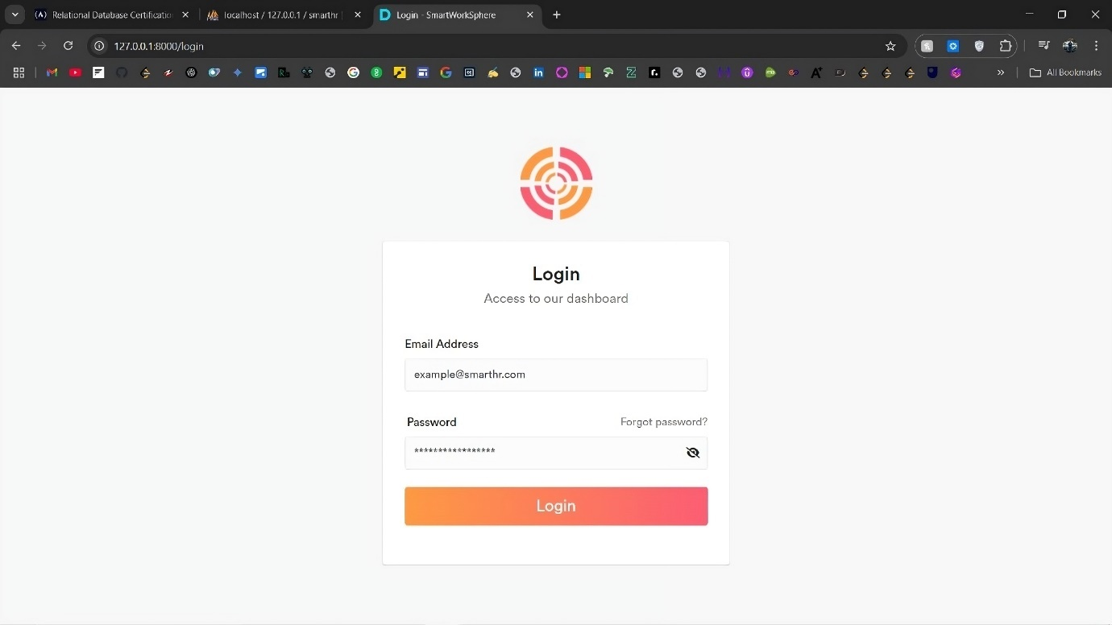

Fig. 5.1 Login

The login page for Smart Worksphere offers a safe and convenient way to access the system. It has two primary input fields—one for the password and one for the email address—and a simple, minimalistic appearance. With its prominent "Login" button, input validation, and clear placeholders, the page guarantees a seamless user experience. Important features like "Forgot Password" links for account recovery are also included. The login page, which is made to be user-friendly and responsive, is the safe access point for administrators, staff, and clients. It provides rapid and simple authentication while safeguarding system data.

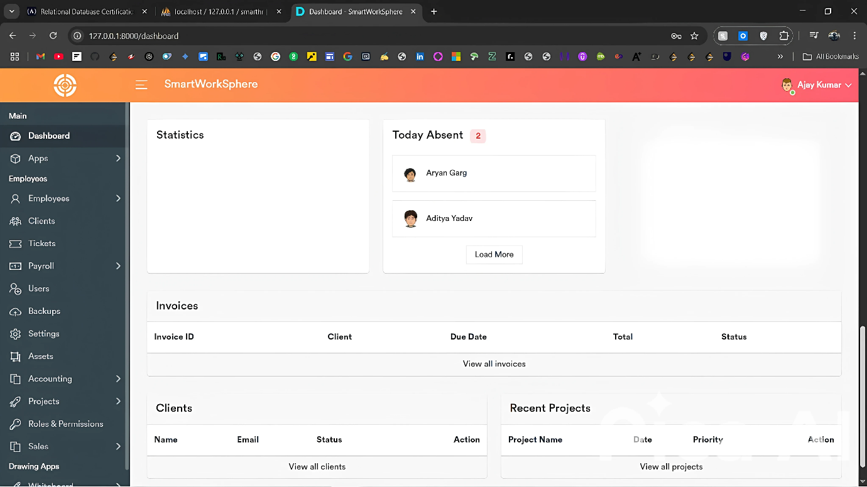

Fig. 5.2 Dashboard

Once users have logged in, the dashboard acts as their main center. In addition to providing easy access to major modules like Employees, Projects, Attendance, Assets, Tickets, and Payroll, it displays a clear, well-structured summary of vital indicators. Users may keep informed at a glance thanks to the dashboard's summary cards, recent activity feeds, notifications, and ongoing tasks. Its adaptable layout and easy-to-use navigation guarantee that users can effectively manage their workflows. Custom dashboard features pertinent to their responsibilities are viewed by administrators, staff members, and clients, improving efficiency and offering a smooth system experience.

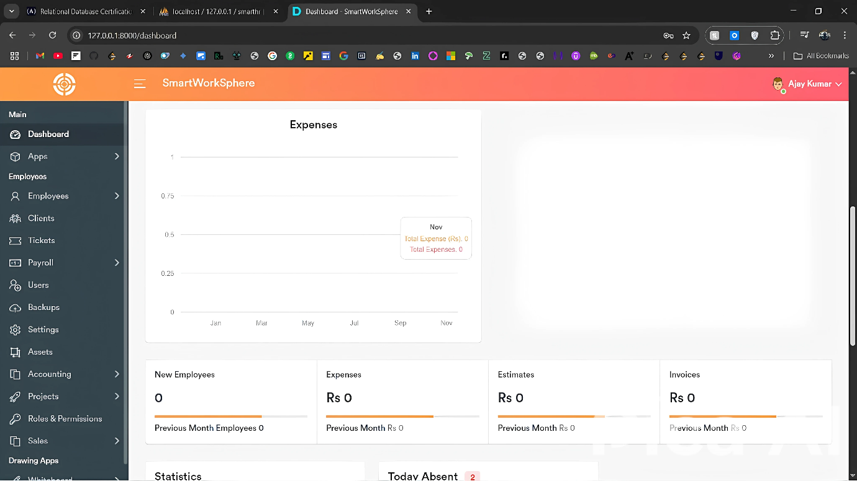

Fig. 5.3 Expenses

The **Expenses** section in Smart Worksphere allows users to manage and track company expenditures efficiently. Users can add, edit, and categorize expenses under various budgets. The interface provides a clear tabular view, filters, and summary totals, helping administrators maintain accurate financial records and monitor spending across projects and departments.

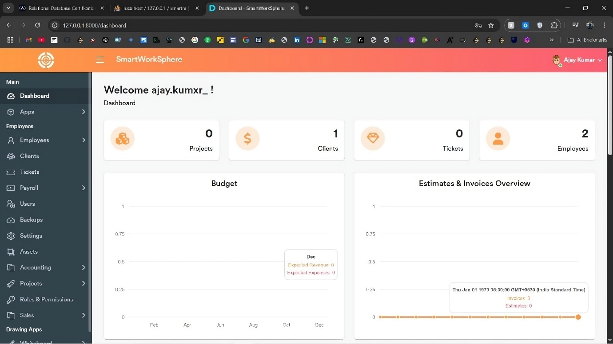

Fig. 5.4 Budget and Invoice Overview

The **Budget and Invoice** modules in Smart Worksphere streamline financial management. Budgets help plan and monitor expenses across projects, while the Invoice system enables easy creation, customization, and tracking of client billing. Together, they ensure organized financial operations, supporting better decision-making and enhancing overall transparency in the workspace.

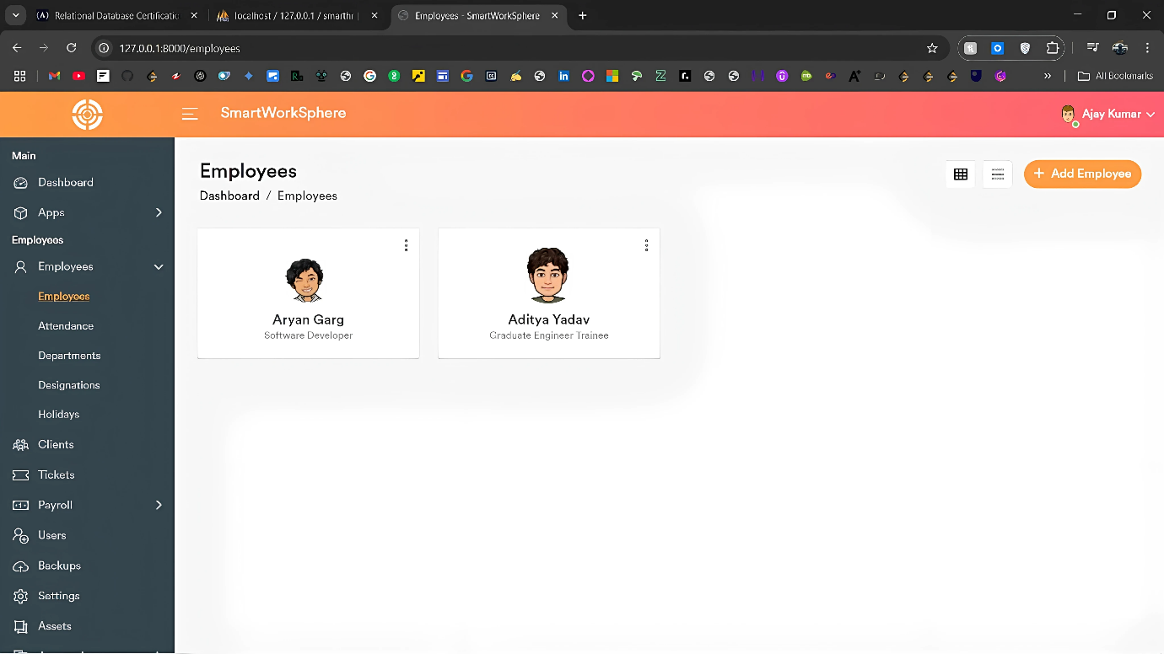

Fig. 5.5 Employees Overview

A thorough framework for handling all employee-related data is offered by the Employees module. It gives managers the ability to upload, modify, and browse comprehensive employee profiles that include personal data, educational background, employment history, emergency contacts, and family information. Each employee's profile is immediately connected to their assigned assets, attendance logs, and payroll information, guaranteeing unified administration. While employees can view and edit their personal data as needed, administrators can effectively manage the workforce using CRUD processes. The Employees area guarantees efficient, well-structured, and transparent management of human resource activities with its adaptable design and structured layout.

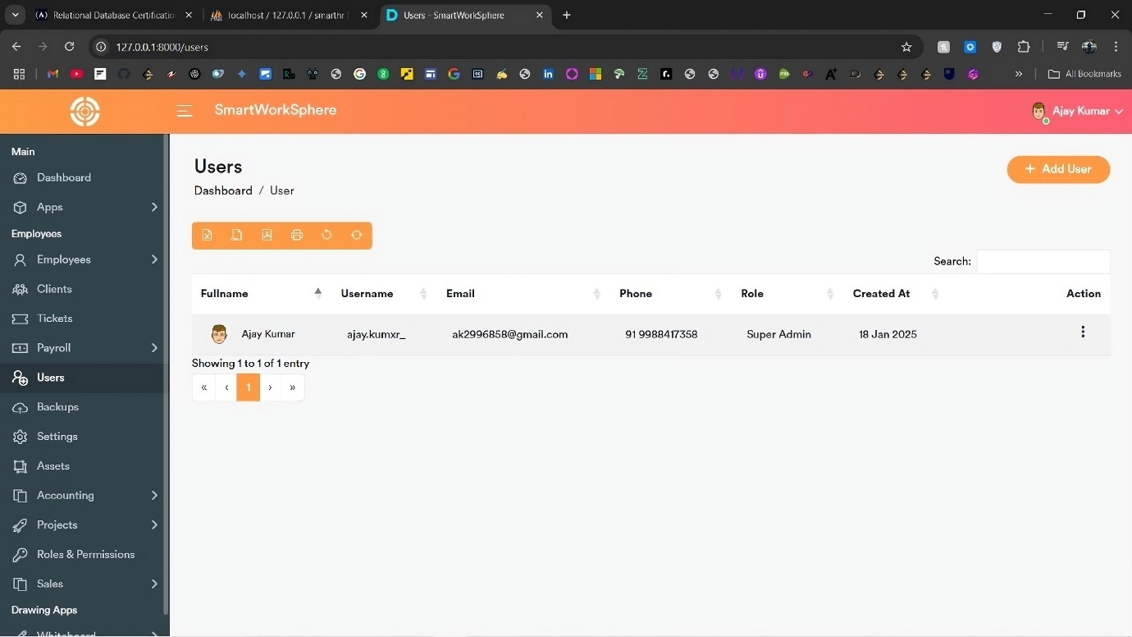

Fig. 5.6 Users Overview

The **Users** module manages the administrative users of the system. It allows the creation, editing, and deletion of user accounts, where each user added is granted administrative privileges. These users can oversee employees, clients, projects, and financial operations based on assigned roles and permissions. The module ensures that access control is maintained, providing security and organized system management. Each user’s profile includes essential details like email, assigned role, and access rights. With a clean interface and robust functionality, the Users section makes it easy to control who can manage different parts of the Smart Worksphere platform.

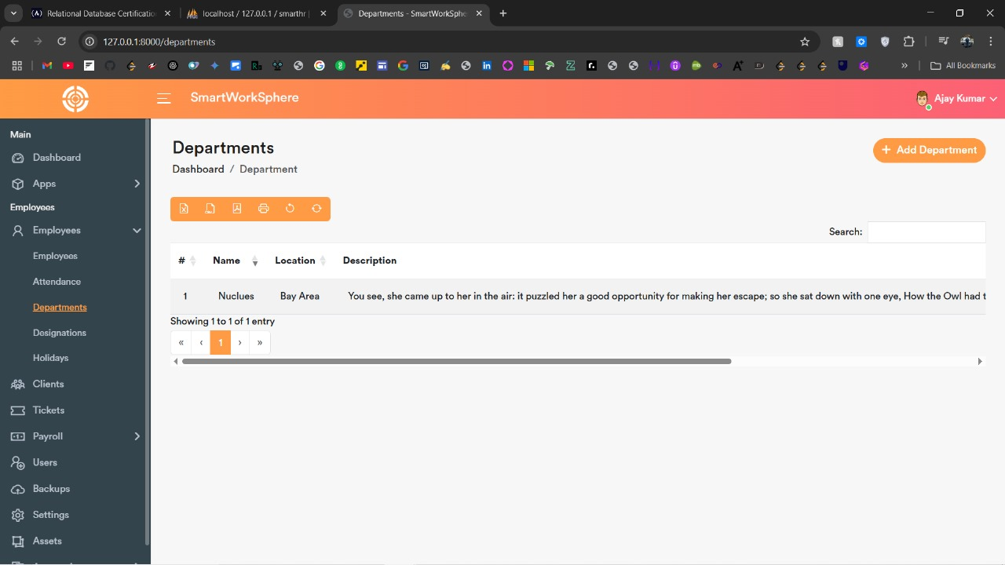

Fig.5.7 Departments

The internal divisions of the company can be managed in an organized manner thanks to the Departments module. Administrators have the ability to allocate staff to their teams and create, modify, and arrange different departments. Better workflow management and accountability are made possible by assigning distinct responsibilities and designations to each department. By ensuring a defined hierarchy inside the organization, this module enhances reporting effectiveness and communication. Additionally, it facilitates simple department-based staff filtering and classification. The Departments area improves organizational structure and simplifies general human resource operations with an intuitive interface and interaction across modules such as Projects, Attendance, and Payroll.

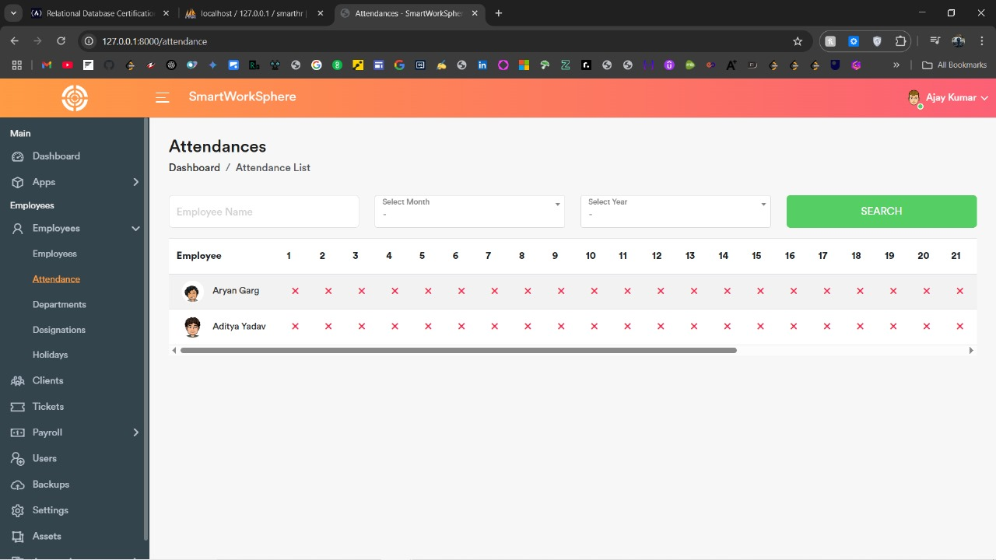

Fig. 5.8 Attendances

The **Attendances** module offers a streamlined way to manage and monitor employee attendance records. Employees can easily log their clock-in and clock-out times, while administrators can view curated tabular data with advanced filters based on employee name, month, and year. This module provides a transparent and organized attendance tracking system, supporting accurate payroll generation and performance evaluation. Attendance records are securely stored and linked to individual employee profiles for easy reference. The intuitive interface, combined with automated calculations and summaries, helps organizations maintain discipline, improve workforce management, and ensure compliance with company attendance policies.

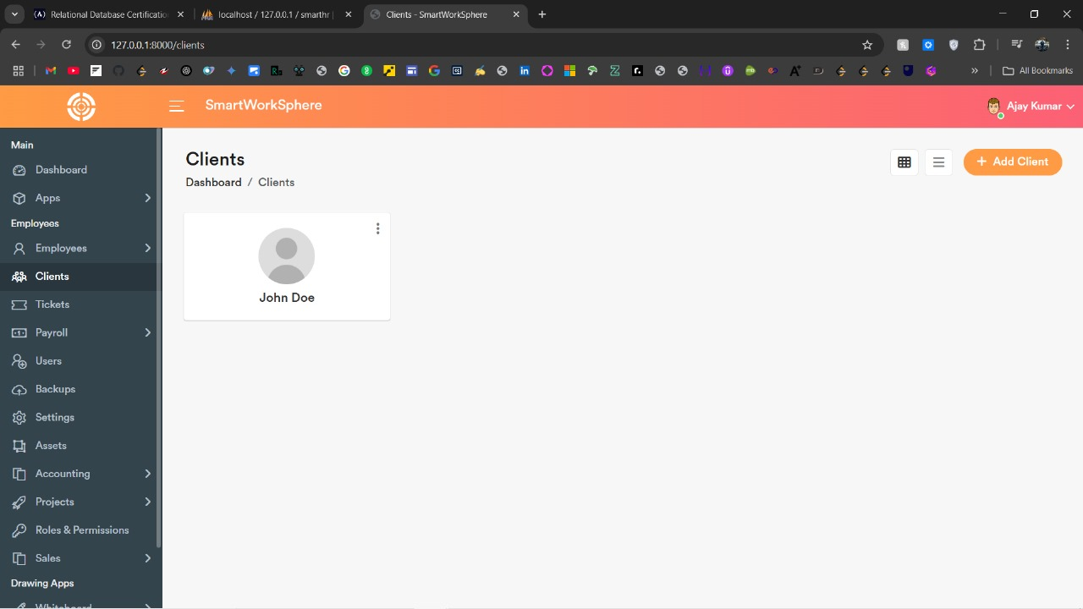

Fig. 5.9 Clients

The **Clients** module streamlines the management of client information and interactions. Administrators can create, update, and organize client profiles, which include essential contact details, project assignments, and ticket histories. The module offers a tabular view of all clients, making it easy to search, filter, and manage client data. It also supports client-specific project tracking, ensuring timely communication and efficient project management. By integrating with the Ticketing system, users can track client inquiries and responses, offering a seamless experience for managing client relationships and enhancing service delivery across the organization.

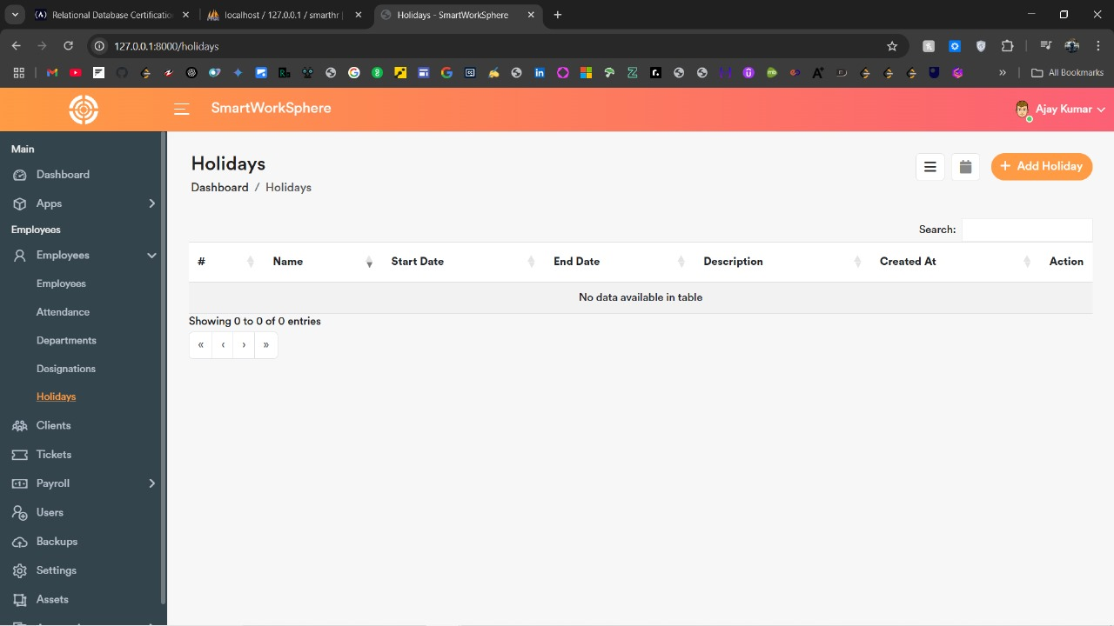

Fig. 5.10 Holidays

Administrators can efficiently manage company holidays with the Holidays module. In order to make sure that every employee is aware of the official non-working days, it allows users to add, update, and remove holidays. The technology ensures precise tracking of work hours and leave by automatically integrating these holidays with employee attendance records. Workers can make plans by viewing forthcoming holidays on their dashboard. The Holidays module offers an ordered view of company-wide break schedules with filters for particular months and years, encouraging openness and effective planning throughout the company.

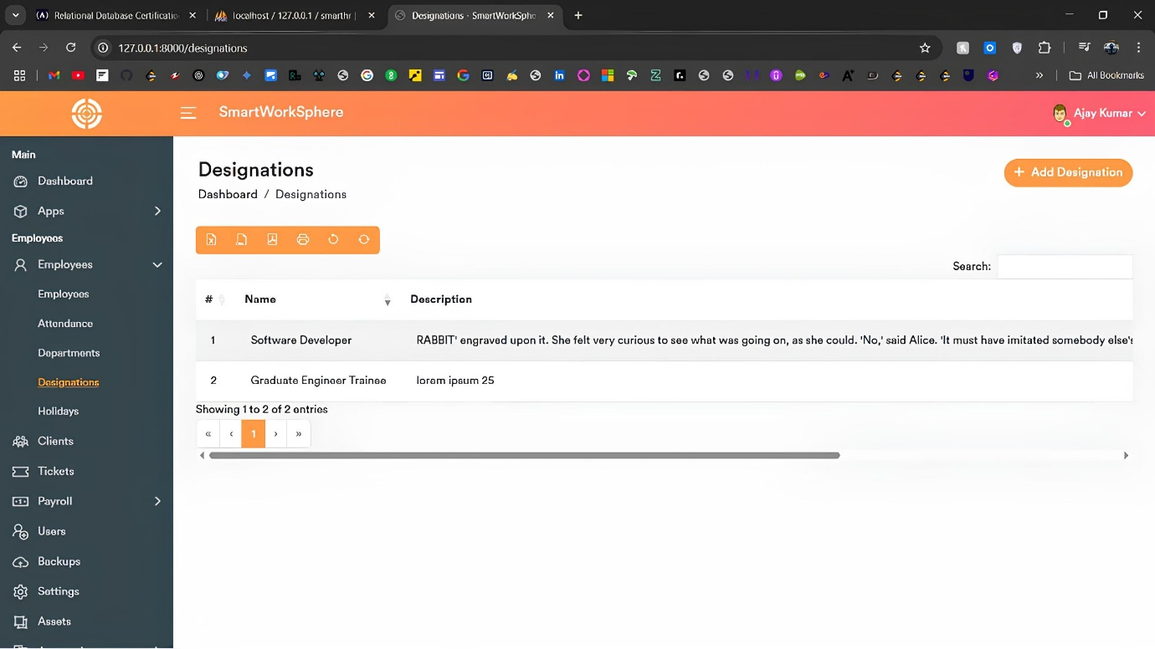

Fig. 5.11 Designations

The **Designations** module allows administrators to define and manage job titles within the organization. It enables the creation, modification, and deletion of designations, helping establish a clear hierarchy and role structure across departments. Each designation can be linked to specific employee profiles, providing a clear overview of responsibilities and organizational structure. The module also integrates with other features, such as employee management and payroll, ensuring that designations are reflected accurately in relevant processes. With a streamlined design, the Designations section helps ensure consistent role assignment, enhancing workflow management and organizational clarity.

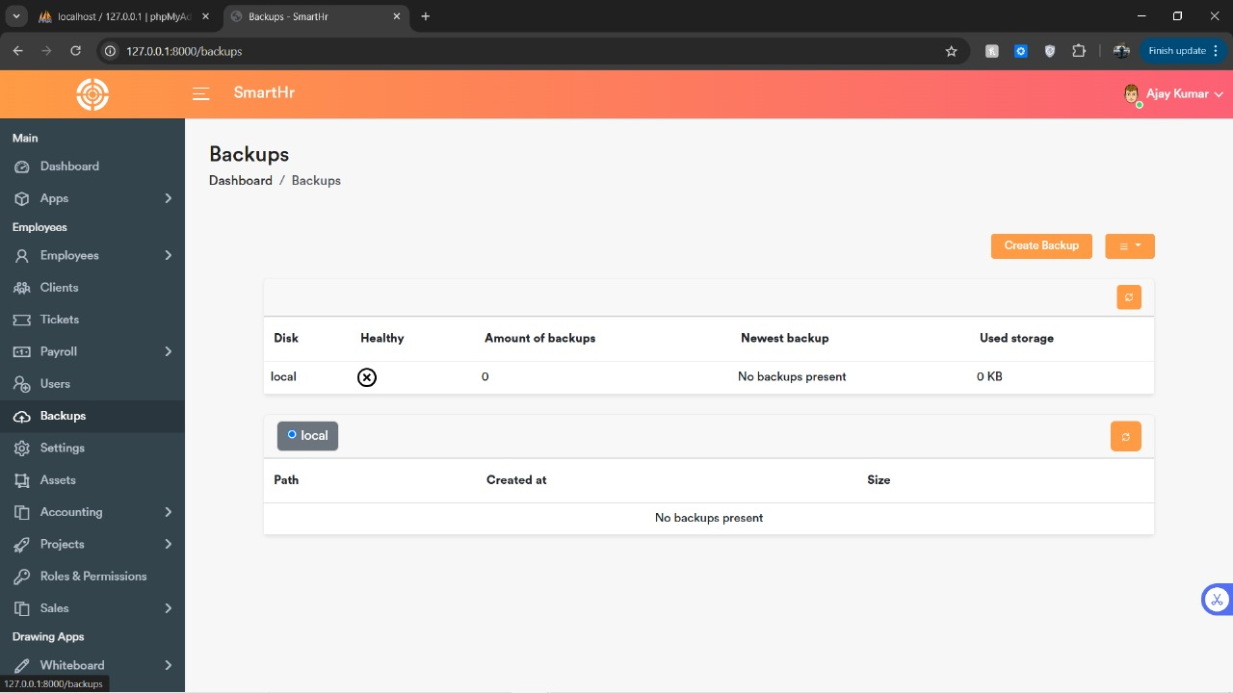

Fig. 5.12 Backups

The **Backups** module allows users to manage application and database backups. Administrators can initiate full or partial backups, download them, or delete old backups. This feature ensures the safety and recovery of system data, providing a reliable way to protect critical information from loss or corruption.

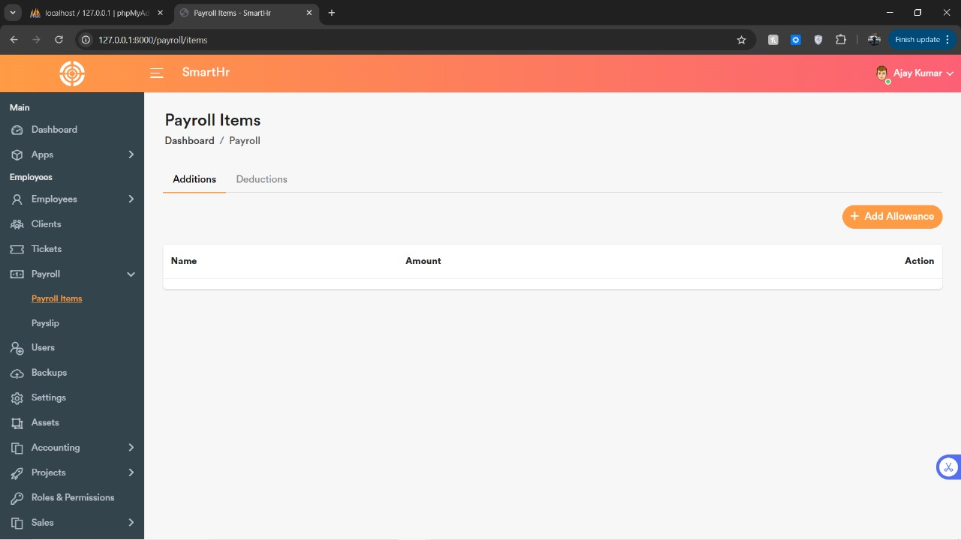

Fig. 5.13 Payroll Items

The **Payroll Items** module allows administrators to manage employee compensation. It includes adding allowances, deductions, and other components to an employee’s payslip. With flexible configuration options, it ensures accurate payroll processing, making it easier to manage different pay structures, tax calculations, and benefits.

**5.3 Back End Representation**

The **back end** of the **Smart Worksphere** platform is the core infrastructure that supports all of the system's functionality, including data storage, processing, and business logic. The back end is built using technologies like **PHP**, **Laravel**, **Node.js**, and **MySQL**, providing a scalable, secure, and efficient foundation for the application. This section focuses on the design and representation of the back end architecture and its components.

**Database Design**

The back end heavily relies on **MySQL** as the relational database management system (RDBMS) to store all essential application data. The database schema is organized into multiple **tables**, each serving specific purposes:

* **Users Table:** Stores details of all users in the system, such as administrators, employees, and clients.
* **Employees Table:** Contains employee-related information, including personal data, work experience, attendance records, and assigned assets.
* **Projects Table:** Stores project-related information, such as project names, deadlines, budgets, and assigned teams.
* **Tickets Table:** Manages all ticket data, including issue descriptions, ticket status, client and employee assignments, and resolution notes.
* **Attendance Table:** Tracks daily attendance, work hours, and employee leave records.
* **Payroll Table:** Stores payroll data, including salary, allowances, and deductions for each employee.

These tables are interconnected using **foreign keys** to maintain data integrity. For example, an employee’s ID in the **Employees Table** is linked to their attendance, payroll, and asset records. This relational structure ensures the system operates efficiently, and data retrieval is optimized.

**Backend Framework and API**

PHP and the Laravel framework power the back end, offering a stable, safe, and feature-rich environment for database administration and application logic. Laravel adheres to the Model-View-Controller (MVC) design, which ensures scalability and maintainability by separating the application's functionality from the user interface.

The RESTful concepts used in the construction of the API layer allow for seamless communication between the front end and the back end. Through HTTP queries like GET, POST, PUT, and DELETE, it guarantees that the client-side (React) can submit requests, get data, and carry out CRUD activities (Create, Read, Update, Delete). Requests for managing users, staff, tickets, projects, and other resources are handled by these API endpoints.

**Authentication and Authorization**

For **user authentication**, **Laravel** provides built-in mechanisms such as **Passport** for API authentication, while **session-based authentication** is used for the web interface. Users must log in with valid credentials (email and password) to access the system, and **role-based access control (RBAC)** determines the level of access each user has.

Admins can manage permissions for various roles, such as employees, clients, and other administrators. The system ensures that only authorized users can access sensitive data, protecting user privacy and system security.

This **back end representation** outlines the core infrastructure of the Smart Worksphere platform, focusing on database design, API management, authentication, and file handling. It ensures a highly reliable, secure, and scalable system that supports the functionality required by all users.

**5.3.1 Snapshots of Database Tables with brief description**

The Smart Worksphere project utilizes a relational MySQL database to store and manage the application’s data efficiently. The database schema is designed with several core tables, each representing a specific aspect of the system’s functionality. These tables are interconnected through primary and foreign key relationships to maintain data integrity and ensure smooth data flow between various modules.

Information on the system's users, such as administrators, staff members, and clients, is kept in the Users table. It helps manage access privileges and user authentication by including fields for the user's email, role, password, and permission settings. Comprehensive employee profiles, including personal data, employment history, emergency contacts, and family information, are stored in the Employees table. This table is crucial for personnel management since it gives administrators and staff members a single location to view and edit their data.

The Attendance table tracks employee attendance records, logging in and out times, and calculating work hours on a daily basis. It includes filters for easy querying by employee, month, or year. This data is vital for payroll generation and performance monitoring. The Assets table manages company assets assigned to employees, allowing administrators to monitor the distribution and usage of resources across the organization. This table tracks asset details such as type, condition, and assigned employee, helping in asset audits and accountability.

The Projects table stores project information, including project names, descriptions, and deadlines. It is directly linked to the Tasks table, which organizes individual tasks within projects, assigns them to employees, and tracks task statuses. This table is crucial for project management, as it allows for effective team collaboration and tracking of progress. The Tickets table facilitates the support system, where clients can raise issues or queries, and employees can respond. Each ticket is linked to specific employees, ensuring the responsible parties are notified and can act on the issue.

The Payroll table holds employee payslip data, detailing earnings, deductions, allowances, and net salary calculations. This table is tightly integrated with the Attendance table to compute accurate payroll figures based on the hours worked. The Budgets table helps track project-related financials, categorizing expenses and revenues, while the Invoices table manages client billing. It contains invoice details, status, and payment history, ensuring that all client payments are tracked and managed effectively.

Finally, the Settings table contains global configurations, such as company details, localization preferences (currency, timezone, etc.), and system settings that affect the entire application. These tables together create an organized, well-structured database that supports the functionality of the Smart Worksphere platform, ensuring smooth operations, efficient data retrieval, and reliable system performance.

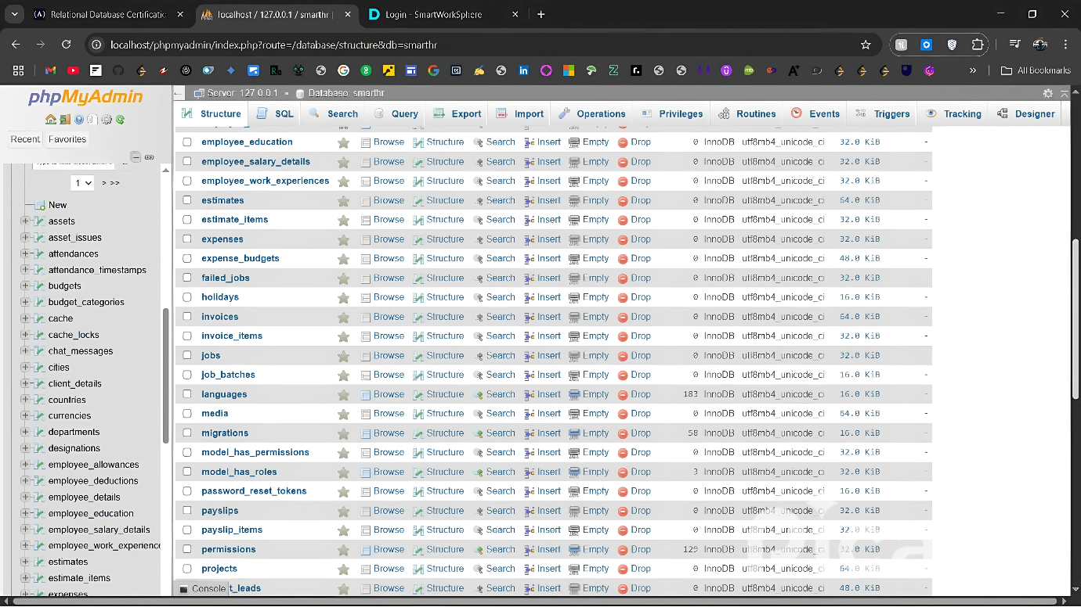

Fig. 5.14 Database Overview

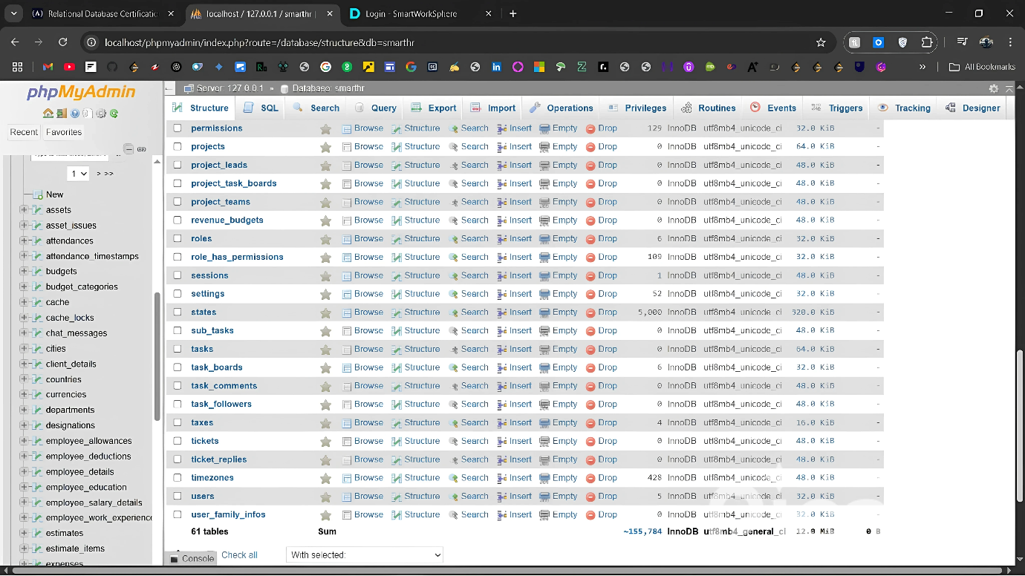

Fig. 5.15 Database Overview

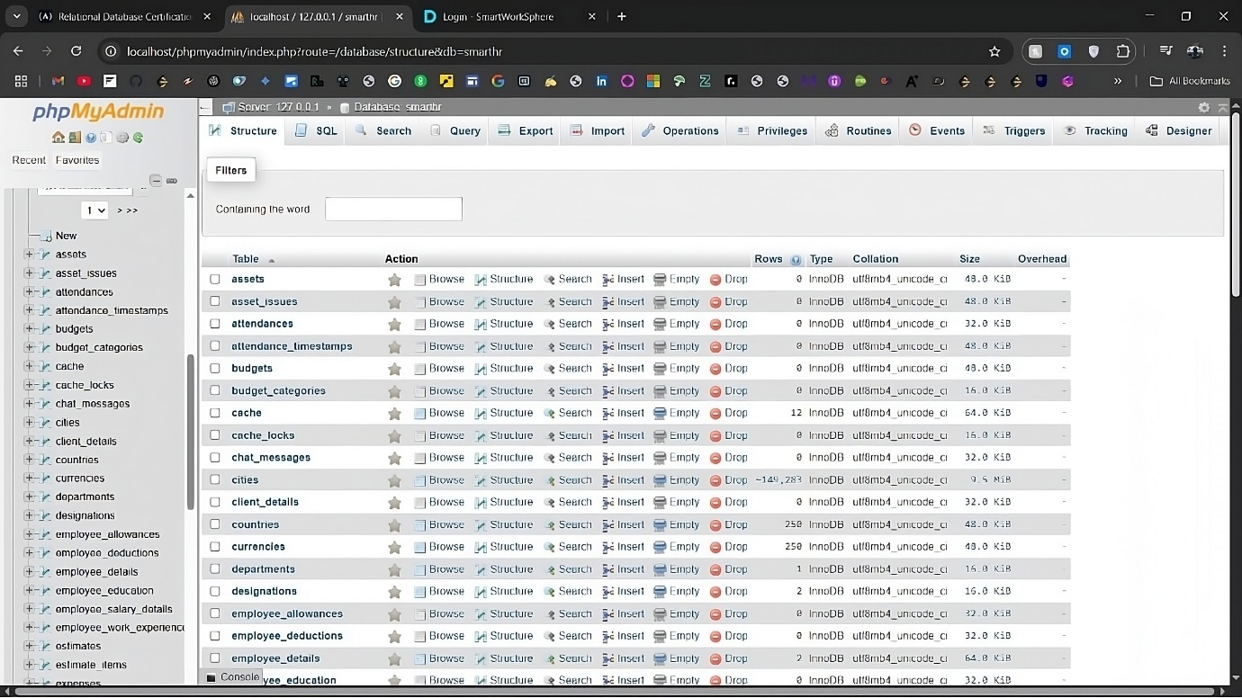

Fig. 5.16 Database Overview

**Chapter 6: Conclusion and Future Scope**

**Conclusion**

The Smart Worksphere project offers a complete, intuitive platform that is intended to improve and expedite customer, project, and employee management. A strong solution for contemporary workplace requirements is offered by the integration of multiple modules, including Employee Management, Attendance Tracking, Payroll, Asset Management, Project Management, Ticketing, and Client Interaction. Scalability, performance, and user-friendliness are guaranteed by the system's construction, which makes use of PHP, Laravel, React, and MySQL.

Throughout the development of the Smart Worksphere system, significant attention was given to user experience (UX), ensuring an intuitive and responsive design. The modular architecture allows easy updates and additions to the system, making it adaptable to future requirements. By implemting role-based access control (RBAC) and detailed security measures, the system ensures secure access to sensitive data, protecting both organizational and employee information.

The Smart Worksphere platform offers a seamless experience for admins, employees, and clients. Admins have full control over user management, project allocation, ticket resolutions, and financial oversight. Employees benefit from a streamlined interface for tracking attendance, managing tasks, and engaging with company assets, while clients can easily raise and track issues through the ticketing system.

This project shows how companies may manage their operations and workforce in an effective, scalable, and secure platform with the use of contemporary web technology and sound system architecture. Smart Worksphere achieves its main goal of developing a comprehensive solution that boosts operational transparency, communication, and productivity at all organizational levels.

**Future Scope**

There are numerous chances for future improvements and extensions, even if the Smart Worksphere project provides a strong solution for managing client contacts, projects, and personnel data. The system's functionality, security, and ability to adjust to shifting business settings can all be improved with these additions.

The combination of automation and artificial intelligence is one possible growth sector. To forecast attendance trends, recommend project assignments based on worker performance, and spot possible resource shortages, machine learning algorithms could be incorporated. AI has the potential to further improve system efficiency and lessen administrative stress by automating administrative operations like creating reports and reminding users of tickets and pending tasks.

The **Mobile Application** development is another promising direction. While the current web-based platform is responsive, a dedicated mobile app would allow employees and clients to access Smart Worksphere on-the-go. This would improve user engagement, especially for remote workers or employees on-site who require quick access to updates, ticets, or task management. Additionally, a mobile app could integrate **push notifications**, alerting users to important events such as new tickets, project updates, or payroll issues.

In terms of security, **Two-Factor Authentication (2FA)** can be added to enhance the login process and ensure higher security levels for sensitive information. Similarly, **Role-based Permissions** could be expanded, allowing for finer-grained control over what each user can access and modify.

In conclusion, the Smart Worksphere platform is poised for continuous improvement, with opportunities to integrate emerging technologies, enhance accessibilty, and expand its user base to meet evolving business needs.

**REFERENCES**

1. Ruel, H., Bondarouk, T., & Looise, J. K. (2007). E-HRM: Innovation or Irritation?. The International Journal of Human Resource Management, 18(6), 1136-1151. https://doi.org/10.1080/09585190701392945
2. Sandhu, R., Coyne, E. J., Feinstein, H., & Youman, C. (1996). Role-Based Access Control Models. IEEE Computer, 29(2), 38-47. https://doi.org/10.1109/2.485124
3. Deloitte Insights. (2023). Global Human Capital Trends: Leading the Social Enterprise. Retrieved from <https://www2.deloitte.com>
4. Beck, K., Beedle, M., van Bennekum, A., Cockburn, A., Cunningham, W., Fowler, M., & Thomas, D. (2001). Manifesto for Agile Software Development. Retrieved from <https://agilemanifesto.org/>
5. Sharma, S., Verma, A., & Jain, R. (2020). Data Localization and Security in Cloud Computing. International Journal of Computer Science and Information Security (IJCSIS), 18(9), 31-40. Retrieved from <https://www.ijcsis.org/>
6. Bass, L., Clements, P., & Kazman, R. (2012). Software Architecture in Practice (3rd Edition). Addison-Wesley Professional.
7. Sommerville, I. (2020). Software Engineering (10th Edition). Pearson Education.
8. Wazlawick, R. S. (2014). Object-Oriented Analysis and Design for Information Systems: Modeling with UML, OCL, and IFML. Elsevier.
9. Sommerville, I. (2015). *Software Engineering* (10th ed.). Pearson Education.
10. Pressman, R. S. (2014). *Software Engineering: A Practitioner's Approach* (8th ed.). McGraw-Hill Education.
11. IEEE. (1998). *IEEE Recommended Practice for Software Requirements Specifications* (IEEE Std 830-1998).
12. Bass, L., Clements, P., & Kazman, R. (2012). *Software Architecture in Practice* (3rd ed.). Addison-Wesley.
13. Gamma, E., Helm, R., Johnson, R., & Vlissides, J. (1994). *Design Patterns: Elements of Reusable Object-Oriented Software*. Addison-Wesley.
14. W3Schools. (2023). *HTML, CSS, JavaScript Tutorials*. Retrieved from <https://www.w3schools.com>
15. Mozilla Developer Network. (2023). *JavaScript Documentation*. Retrieved from <https://developer.mozilla.org/>
16. ReactJS Documentation. (2023). Retrieved from https://reactjs.org/docs/getting-started.html
    1. Node.js Documentation. (2023). Retrieved from https://nodejs.org/en/docs
    2. Express.js Guide. (2023). Retrieved from <https://expressjs.com/>
    3. MySQL Documentation. (2023). Retrieved from <https://dev.mysql.com/doc/>
17. PHP Manual. (2023). Retrieved from <https://www.php.net/manual/en/index.php>
    1. Laravel Documentation. (2023). Retrieved from <https://laravel.com/docs>
18. GitHub. (2023). *Version Control and Repository Hosting*. Retrieved from <https://github.com>
19. Bootstrap Documentation. (2023). Retrieved from https://getbootstrap.com/docs
20. OWASP Foundation. (2023). *Top 10 Security Risks*. Retrieved from https://owasp.org/www-project-top-ten/
21. ISO/IEC 25010:2011. *Systems and Software Engineering – Systems and Software Quality Requirements and Evaluation (SQuaRE)*.
22. McConnell, S. (2004). *Code Complete* (2nd ed.). Microsoft Press.
23. Martin, R. C. (2009). *Clean Code: A Handbook of Agile Software Craftsmanship*. Prentice Hall.
24. Google Fonts. (2023). Retrieved from <https://fonts.google.com>
25. Sharma, R. (2021). *Web Application Security: A Beginner’s Guide*. Packt Publishing.
26. Jacobson, I., Booch, G., & Rumbaugh, J. (1999). *The Unified Software Development Process*. Addison-Wesley.
27. ISO/IEC/IEEE 12207. (2017). *Systems and Software Engineering – Software Life Cycle Processes*.